Implementation of Databases Notes

Table of Contents

1. Architecture of Database Systems 3

1.1 Goals and Tasks of DBMS 3

1.2 Basic Architecture of DBMS 4

1.3 Distributed Database Systems 4

2. Advanced Transaction Management 4

2.1 Definitions 4

2.2 Synchronization Problems 5

ACID Principle 6

2.3 Serializability Theory 6

Definitions 6

2.4 Conflict Serializability Classes 7

8

8

8

2.5 Recovery Theory 9

9

9

10

10

2.6 Scheduling Algorithms 10

Locking Scheduler 10

Two Phase Locking (2PL) 11

Multi-Granularity Locking (MGL) 11

Index Locking 12

B+ Trees and the Simple Locking Algorithm 13

2.7 Recovery Protocols 14

ARIES 17

2.8 Distributed Transactions and the CAP Theorem 17

3. Relational Queries 18

3.1 Implementing Single-Relational Operators 19

Sorting 19

Selection 19

Projection, Union and Difference 19

Aggregate Functions 19

3.2 Join Algorithms 19

Simple Nested Loop 19

Block Nested Loop Join 19

Index Nested Loop Join 20

Sort-Merge Join 20

Hash Join 20

3.3 Tableaus 21

Tableau Method: Example 21

Tableau Containment and Equivalence 23

Tableau Minimization 25

3.4 Tree-Structured Queries 26

Definitions 26

Quant Graphs 26

3.5 Cost-based Query Optimization 27

Selinger-style query optimization 27

Views and Indexes 32

3.6 Deductive Queries & Integrity Checking 32

Datalog Syntax 33

Deductive Databases (DDBs) 34

3.7 Querying Data Integration Systems 36

4. Big Data & Internet Information Systems 38

4.1 Query Processing in Big Data Systems 38

Map-Reduce 38

4.2 Data Management in the Cloud 40

[[TOC]]

# 1. Architecture of Database Systems

## 1.1 Goals and Tasks of DBMS

* **Data independence** is the main goal of DBMS. It means that data is managed independent of applications. It refers to the immunity of user applications to changes made in the definition and organisation of data. It makes data available for different applications. There are two types of data independences.
  + **Physical data independence**: logical schema is independent of physical structure, i.e., relational schema is independent of changes on indexes, clustering, etc.
  + **Logical data independence:** external schema is independent of logical schema, i.e., relational views are defined as derived relations on top of logical schema (the relational schema with the base relations); logical schema might change while external schema does not need to be changed.
* **Five layers**
  + **Logical Data Structure** is mainly for translating and optimising queries. The addressing units between this layer and Transaction Programs are views, tuples and tables. The auxiliary structure is external schema description. And the addressing units to the lower level are external records, sets, keys and access paths. The interface between transaction programs or users and Logical Data Structure is Set‐Oriented Interface (SQL).
  + **Logical Access Structure** is mainly for managing cursors, sorting components and managing dictionaries. The auxiliary structures are access path data and internal schema description. The addressing units to the lower layer are internal records, B* trees and so on. The interface between Logical Data Structure and Logical Access Structure is Record Oriented Interface for offering logical access path to individual records.
  + **Storage Structure** is responsible for managing records and indexes. The auxiliary structures are DBTT, FPA, page indexes and so on. The addressing units to the lower layer include page and segments. The interface between Logical Access Structure and Storage Structure is Internal Record Interface, in which records are stored in B* tree.
  + **Page Assignment** is for managing buffers and segments. The auxiliary structures are page and block tables. The addressing units to the lower layer include blocks and files. The interface between Storage Structure and Page Assignment is System Buffer Interface.
  + **Memory Assignment Structure** is responsible for managing files and external memories. The auxiliary structures are VTOC, extent tables and system catalogue. The addressing units to Physical Volume are tracks, cylinders, channels and so on. The interface between Page Assignment and Memory Assignment Structure is File Interface. And the interface between Memory Assignment Structure and Physical Volume is Device Interface.

## 1.2 Basic Architecture of DBMS

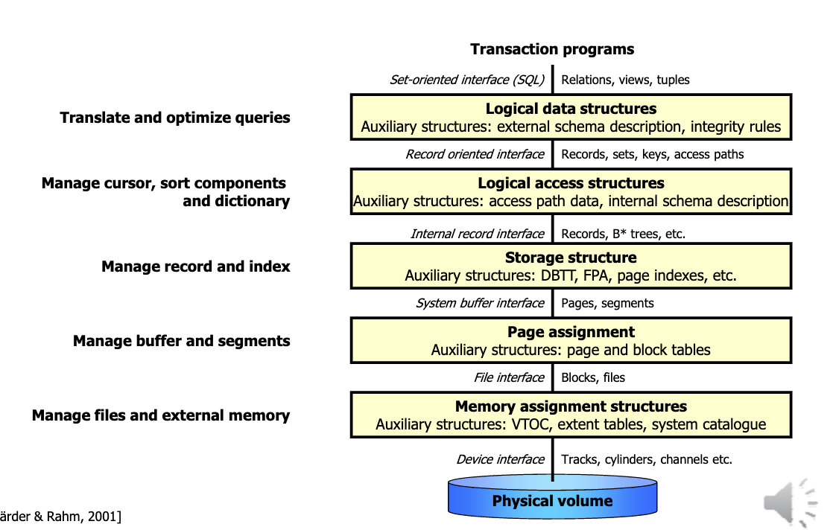

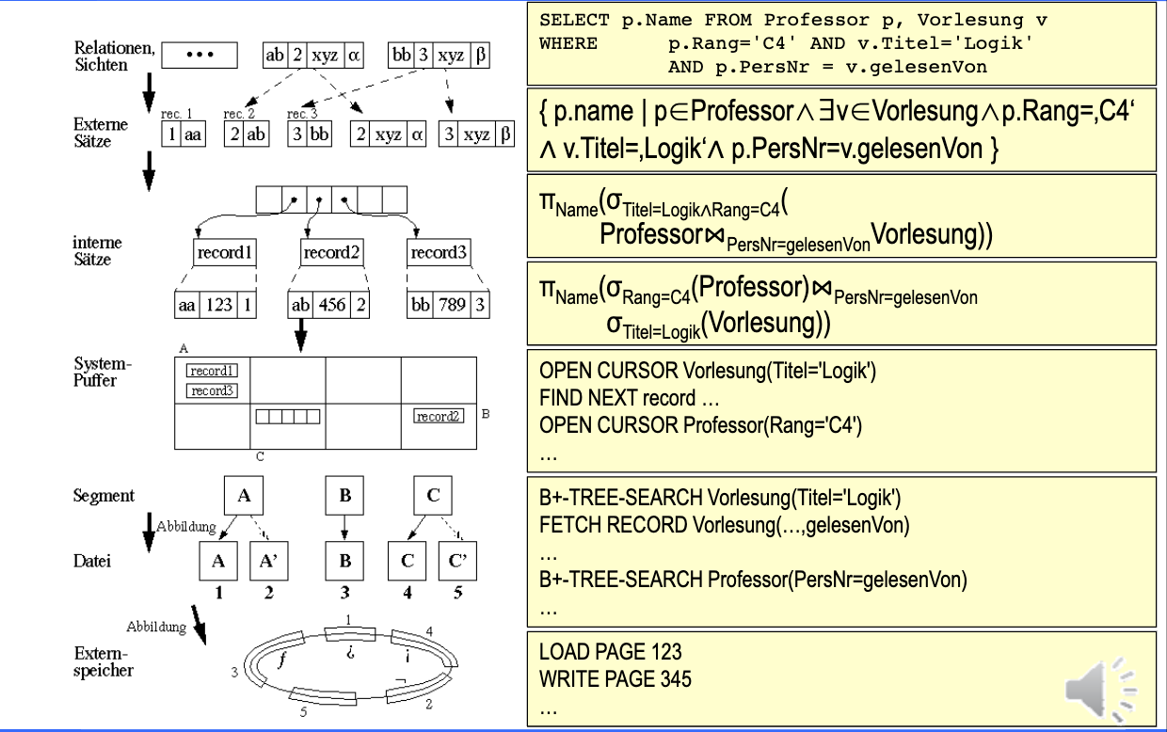

## 1.3 Distributed Database Systems

# 2. Advanced Transaction Management

## 2.1 Definitions

1. A **transaction(TX)** is a DB program, which only consists of read and write operations to a database. These operations are denoted as read(x)or write(x), where xis a DB object.
2. Let $D=\{x,y,z...\}$ be a database. Then a **transaction $t(TX)$** is a finite series of operations in the form $r(x)$ („read x“) or w(x) („write x“) denoted as $t=p_{1},...,p_{n}$ with $n<∞$, $p_{i}∈\{r(x),w(x)\}$ for $1≤i≤n$ and $x∈D$. Indices are used to distinguish various (concurrent) transactions.
3. Let $T=\{t_{1},...,t_{n}\}$ be a (finite) set of transactions. Thus
   * $shuffle(T)$ is the Shuffle Product of $T$. (the sum of all ways of interlacing them, e.g. $ab⋅xy=abxy+axby+xaby+axyb+xayb+xyab$ )
   * a **complete schedule $s$** for $T$ is a serie $s'∈shuffle(T)$ with the additional pseudo actions $c_{i}$ (commit) and $a_{i}$ (abort) for each $t_{i}∈T$ according to the following rules:
 $(∀i,1≤i≤n)c_{i}∈s⇔a_{i}∉s$

 $(∀i,1≤i≤n)c_{i}$   1. or $a_{i}$ are in $s$, whereever, but after the last action of $t_{i}$
   * $shuffle_{ac}(T)$ is the set of all complete schedules
   * a **schedule** is a prefix of a complete schedule
   * a complete schedule is **serial,** if for a permutation $ρ$ from {1,…,n} it holds that all the transactions run one after the other without any interference with one another (no e.g. dirty read) they are terrible from a performance point of view because we have to wait until a transaction finishes executing to execute the next one:
$$s=t_{ρ(1)}...t_{ρ(n)}$$

4. Notation for Schedule s
   * trans(s) = $\{t_{i}|s\text{ contains actions of }t_{i}\}$
   * commit(s) = $\{t_{i}∈\text{ trans(s) }|c_{i}∈s\}$
   * abort(s)= $\{t_{i}∈\text{ trans(s) }|a_{i}∈s\}$
   * active(s)= trans(s) – (commit(s) $∪$ abort(s))
   * op(s) = set of all the actions occurring in s

## 2.2 Synchronization Problems

* Lost update

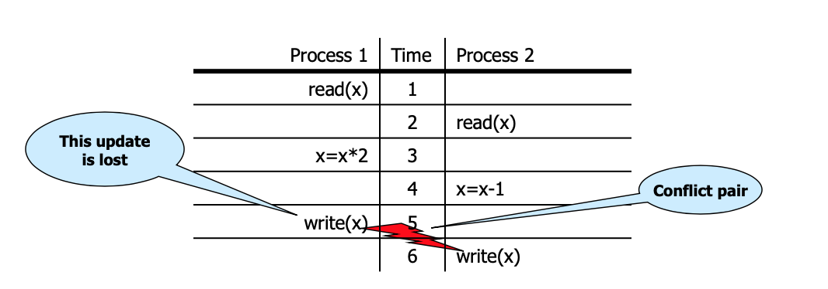

* Dirty read

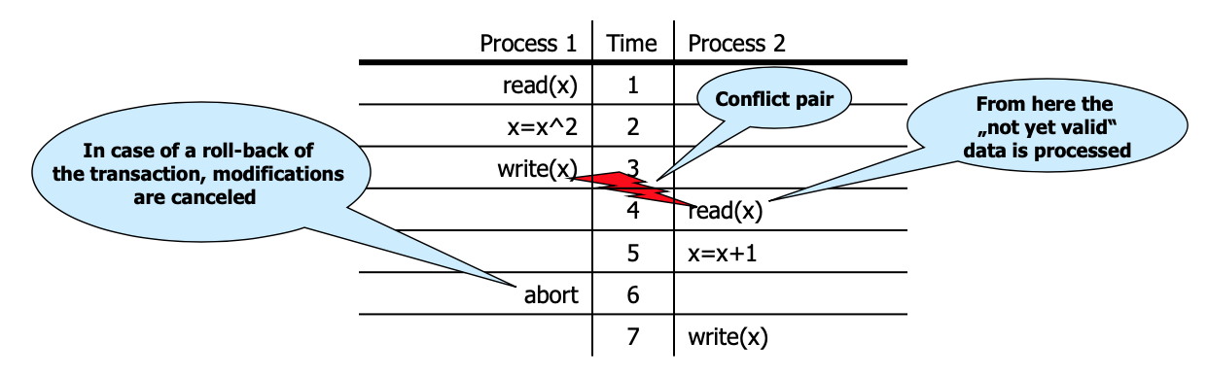

* Non-repeatable read/Inconsistent read

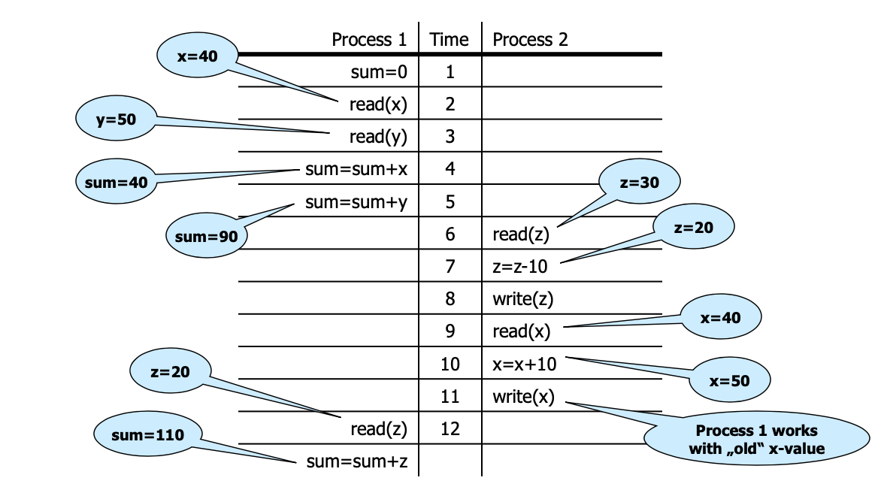

* Phantom Problem

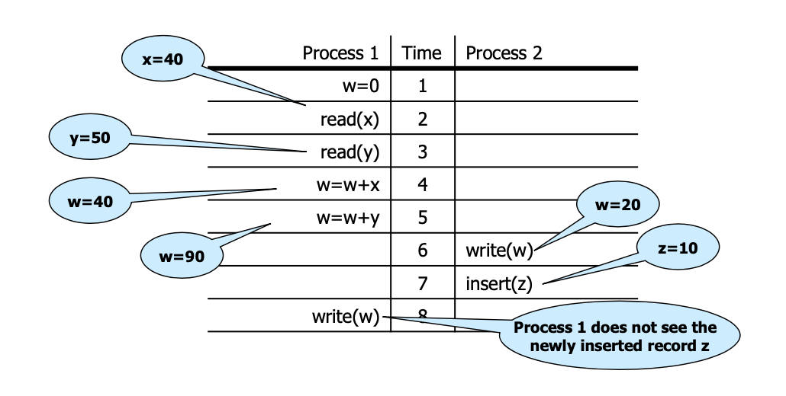

### ACID Principle

Every transaction must be processed in the way that the ACID properties are preserved.

* **Atomicity**: In an execution of a transaction, either all operations are carried out, or none are.
* **Consistency**: Preservation of all integrity constraints of the DB, i.e. a transaction starts with a consistent DB state, and after the execution of the transaction the DB state is consistent as well.
* **Isolation**: Isolated execution of a transaction, i.e. „as if executed solely“
* **Durability**: Once a transaction has been successfully completed, its effects should persist even if the system crashes before all its changes

## 2.3 Serializability Theory

### Definitions

Let $s$ and $s'$ be schedules. $s$ and $s'$ are called **final-state equivalent,** denoted as $s≈_{f}s'$, if $op(s)=op(s')$ and all DB objects have at the end identical values in $s$ and $s'$, according to the abstract semantics.

A schedule $s$ is called **final-state serializable** if there exists a serial schedule $s'$ which is final-state equivalent to $s$. $FSR$ is the class of all final-state serializable schedules.

**Example 1: $s=r1(x)r2(y)w1(y)r3(z)w3(z)r2(x)w2(z)w1(x)$**  
 and $s'=r3(z)w3(z)r2(y)r2(x)w2(z)r1(x)w1(y)w1(x)$ 
.

In $s$: $x=f_{1x}(x_{0})$ $y=f_{1y}(x_{0})$ $z=f_{2z}(x_{0},y_{0})$
In $s'$: $x=f_{1x}(x_{0})$ $y=f_{1y}(x_{0})$ $z=f_{2z}(x_{0},y_{0})$ $$⇒s≈_{f}s'⇒s∈FSR$$

**Example 2: $$s=r_{1}(x)r_{2}(y)w_{1}(y)w_{2}(y)c_{1}c_{2} \\ s'=r_{1}(x)w_{1}(y)r_{2}(y)w_{2}(y)c_{2}c_{1}$$**

In $s:y=f_{2y}(y_{0})$  
In $s':y=f_{2y}(f_{1y}(x_{0}))$ $⇒s$ $≈_{f}s'⇒s∉FSR$

## 2.4 Conflict Serializability Classes

Let $s$ be a schedule, $t,t'∈$ trans(s) and $t≠t'$:

* Two data operations $p∈t$ and $q∈t'$ in $s$ are in **conflict,** if they operate on the same object and at least one of them is a write operation.
* $C(s)=\{(p,q)|p,q$ in $s$ are in conflict and $p$ is before $q$ in $s\}$ are the **conflict relations** of s.

**Example**  
Let $s=w_{1}(x)r_{2}(x)w_{2}(y)r_{1}(y)w_{1}(y)w_{3}(x)w_{3}(y)c_{1}a_{2}$.

Then: $C(s)$ = {($w_{1}(x)$, $r_{2}(x)$), ($w_{1}(x)$, $w_{3}(x)$), ($r_{2}(x)$, $w_{3}(x)$), ($w_{2}(y)$, $r_{1}(y)$), ($w_{2}(y)$, $w_{1}(y)$), ($w_{2}(y)$, $w_{3}(y)$), ($r_{1}(y)$, $w_{3}(y)$), ($w_{1}(y)$, $w_{3}(y)$)}.

$⇒conf(s)=(w_{1}(x),w_{3}(x)),(r_{1}(y),w_{3}(y)),(w_{1}(y),w_{3}(y)).$ Conflict relations with an operation of transaction 2 have been removed.

$conf(s)$ denotes the conflict relations of a schedule s, which are cleaned up by aborted transactions.

Three Serializability classes will be presented: $CSR$, $OCSR$ and $CO$.

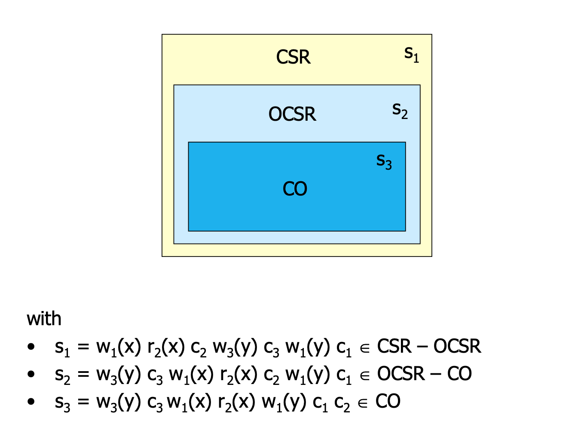

$$CSR$$

### 

* Let $s$ and $s'$ be two schedules. $s$ and $s'$ are called **conflict equivalent**, denoted as $s≈_{c}s'$, if:
  + $op(s)=op(s')$ and
  + $conf(s)=conf(s')$.
* A complete schedule $s$ is called **conflict serializable**, if a serial schedule $s'$ exists with $s≈_{c}s'$.
* The **conflict graph**

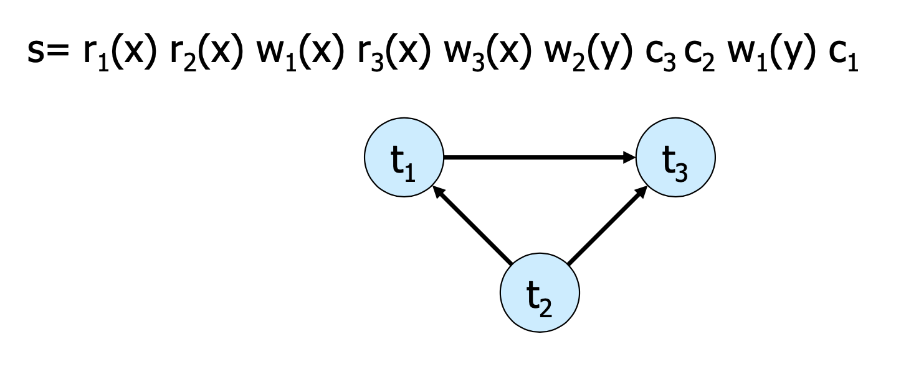

**Theorem 2.2**: $s∈CSR⇔G(s)$ 
 is acyclic.  
(Because the transitions can be ordered $t_{2},t_{1},t_{3}$ in the example)  
**Membership** in CSR can be tested in polynominal time

$$OCSR$$

### 

A complete schedule s is called **order-preserving conflict serializable**, there exists a serial schedule $s'$ with $s≈_{c}s’$ and the following holds for all $t,t'∈trans(s)$:  
If $t$ occurs completely before $t'$ in $s$, then the same holds in $s'$.

$$CO$$

### 

A schedule s is called **commit order-preserving conflict serializable** (or owns the property of **commit order preservation**), if the following holds:  
For all $t_{i},t_{j}∈commit(s),i≠j$, with $(p,q)∈conf(s)$ for $p∈t_{i},q∈t_{j}$,  
then : $c_{i}$ is before $c_{j}$ in $s$.

## 2.5 Recovery Theory

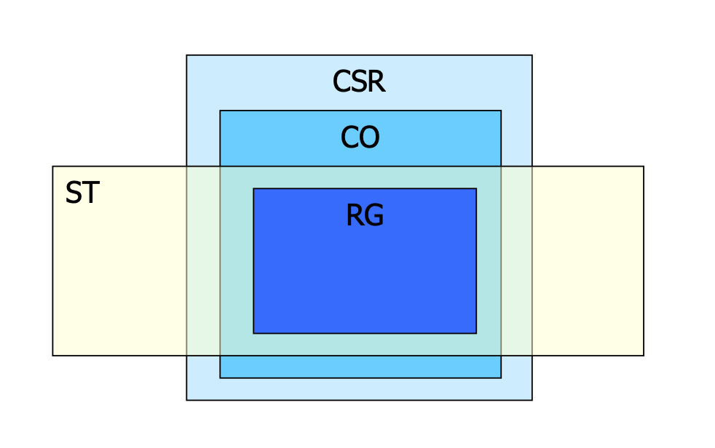

$$RC$$

### 

A schedule s is called **recoverable**, if the following holds: $(∀t_{i},t_{j}∈trans(s),i≠j)$ $t_{i}$
 reads from $t_{j}$ in $s$ $∧c_{i}∈s⇒c_{j}<_{s}c_{i}$ 
(If transaction 2 reads from transaction 1, then transaction 1 commits before transaction 2)  
„Every transaction will not be released, until all other transactions from which it has read, are released.“

**Example**:  
Let $s1=w_{1}(x)w_{1}(y)r_{2}(u)w_{2}(x)r_{2}(y)w_{2}(y)c_{2}w_{1}(z)c_{1}$  
It holds: $t_{2}$ reads $y$ from $t_{1}$ and $c_{2}∈s$, but $c_{1}≮c_{2}$. Consequently $s_{1}∉RC$

Let $s_{2}=w_{1}(x)w_{1}(y)r_{2}(u)w_{2}(x)r_{2}(y)w_{2}(y)w_{1}(z)c_{1}c_{2}$  
It holds: $s_{2}∈RC$, because the commit operation of $t_{2}$ is after the one of $t_{1}$, but the abort of $t_{1}$ leads to the abort of $t_{2}$, this may give rise to cascading aborts.

$$ACA$$

### 

A schedule $s$**avoids cascading aborts**, if it holds: $(∀t_{i},t_{j}∈trans(s),i≠j)$ $t_{i}$
 reads $x$ from $t_{j}$ in $s$ $⇒c_{j}<_{s}r_{i}(x)$ 
„A transaction is only allowed to read values from already successfully completed transactions.“

**Example**: $$s2=w1(x)w1(y)r2(u)w2(x)r2(y)w2(y)w1(z)c1c2∉ACA \\ s3=w1(x)w1(y)r2(u)w2(x)w1(z)c1r2(y)w2(y)c2∈ACA$$ 
Further problem: The values, which are restored after an abort, may be different from the Before Images of the write operations of the aborting transactions.

$$ST$$

### 

A schedule $s$ is called **strict**, if the following holds: $$(∀t_{i}∈trans(s))(∀p_{i}(x)∈op(t_{i}),p∈r,w) \\ w_{j}(x)<_{s}p_{i}(x),i≠j⇒a_{j}<_{s}p_{i}(x)∨c_{j}<_{s}p_{i}(x)$$ 
„A schedule is strict, if an object is not read or overwritten, until the transction, which has written it at last, is terminated.“ (Same as before but now also with the write operation)

**Example**: $$s_{3}=w_{1}(x)w_{1}(y)r_{2}(u)w_{2}(x)w_{1}(z)c_{1}r_{2}(y)w_{2}(y)c_{2}∉ST \\ s_{4}=w_{1}(x)w_{1}(y)r_{2}(u)w_{1}(z)c_{1}w_{2}(x)r_{2}(y)w_{2}(y)c_{2}∈ST$$

$$RG$$

### 

A schedule $s$ is called **rigorous**, if it is strict and satisfies the following condition: $$(∀t_{i},t_{j}∈trans(s))r_{j}(x)<_{s}w_{i}(x),i≠j⇒a_{j}<_{s}w_{i}(x)∨c_{j}<_{s}w_{i}(x)$$ 
„A schedule is rigorous, if it is strict and no object x is overwritten, until all transactions, which have read x at last, are terminated.“

* A schedule from ST avoids Write-Read- as well as Write-Write conflicts between non-released transactions
* A schedule from RG avoids additionally Read-Write conflicts between those kinds of transactions.

## 2.6 Scheduling Algorithms

Techniques with which a DBMS can generate correct schedules for transactions to be processed; these are called scheduling protocols, or in short **scheduler**. A scheduler gets as input a sequence of operations (r,w,a,c) and it must produce a correct output schedule from them.

### Locking Scheduler

The scheduler can apply locks for the synchronization of accesses on data objects that are used together. There are two types of locks for an object x: - Read lock: rl(x) *read lock*, ru(x) *read unlock* - Write lock: wl(x) *read lock*, wu(x) *read unlock*

**Rules for the application of locks**  
For each $t_{i}$, which is contained completely in a schedule $s$, the following should be valid:

1. If $t_{i}$ contains a $r_{i}(x)[w_{i}(x)]$, thus $rl_{i}(x)[wl_{i}(x)]$ stands anywhere before it in $s$ and $ru_{i}(x)[wu_{i}(x)]$ stands anywhere after it.
2. For each $x$ processed by $t_{i}$ there are exactly one $rl_{i}(x)$ resp. $wl_{i}(x)$ in $s$
3. No $ru_{i}/wu_{i}$ is redundant

**Examples: $$s_{1}=rl_{1}(x)r_{1}(x)ru_{1}(x)wl_{2}(x)w_{2}(x)wl_{2}(y)w_{2}(y)wu_{2}(x)wu_{2}(y)c_{2}wl_{1}(y)w_{1}(y)wu_{1}(y)c_{1} \\ s_{2}=rl_{1}(x)r_{1}(x)wl_{1}(y)w_{1}(y)ru_{1}(x)wu_{1}(y)c_{1}wl_{2}(x)w_{2}(x)wl_{2}(y)w_{2}(y)wu_{2}(x)wu_{2}(y)c_{2}$$**

A scheduler **works according to a locking protocol**, if for every output $s$ and every $t_{i}∈trans(s)$ it holds: - $t_{i}$ satisfies the rules 1. to 3 for the application of locks. - If $x$ is locked by $t_{i}$ and $t_{j},t_{i},t_{j}∈trans(s),i≠j$, then these locks are compatible

### Two Phase Locking (2PL)

A locking protocol is **two phase**, if for every generated schedule $s$ and every transaction $t_{i}∈trans(s)$ it holds:  
After the first $ou_{i}$ action there is no further $ql_{i}$ action $(o,q∈\{r,w\})$. Such a scheduler is called a **2PL scheduler**.  
“In the first phase of a transaction locks will only be set, in the second phase locks will only be removed.”

**Examples**: $$s_{1}=rl_{1}(x)r_{1}(x)ru_{1}(x)wl_{2}(x)w_{2}(x)wl_{2}(y)w_{2}(y)wu_{2}(x)wu_{2}(y)c_{2}wl_{1}(y)w_{1}(y)wu_{1}(y)c_{1}s_{1}$$ 
 is not 2PL. $s_{2}=rl_{1}(x)r_{1}(x)wl_{1}(y)w_{1}(y)ru_{1}(x)wu_{1}(y)c_{1}wl_{2}(x)w_{2}(x)wl_{2}(y)w_{2}(y)wu_{2}(x)wu_{2}(y)c_{2}$ $s_{2}$ 
 is 2PL

**Theorem 2.2 $$ε(2PL)⊆CSR$$**

**Variants of 2PL** - Conservative 2PL : All locks are available since BOT - Strict 2PL (S2PL): Hold all write locks till EOT - Strong 2PL (SS2PL): Hold all locks till EOT

**Theorem 2.3 $$ε(S2PL)⊆CSR∩ST$$**

### Multi-Granularity Locking (MGL)

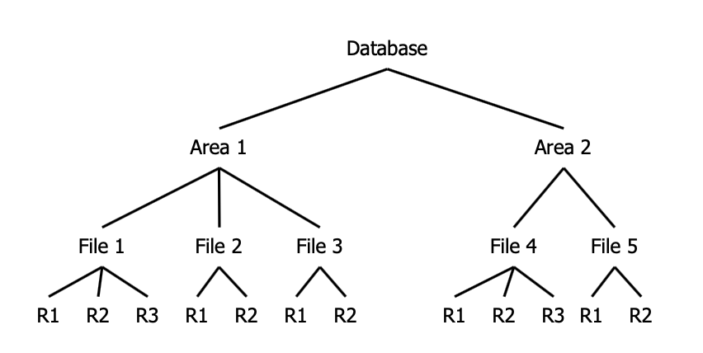

* Each transaction can choose the suitable granularity by itself. (in the example below: record file, table space, area, database) (You can choose to lock the entire File 1 or Area 2 for example)(If something below is locked, you can’t lock above, that’s where intention locks come in handy)
* The scheduler must then prevent transactions from setting conflicting locks in overlapping granularities.

If the database is tree-structured, two provisions are helpful : - Distinction between explicit and implicit locks (higher-level locks implicitly lock also lower level objects) - Propagation of locks in tree upwards as **intention locks** ($irl$, $iwl$, $riwl$)

Each transaction $t_{i}$ is locked/unlocked as follows: 1. If $x$ is not the root of the database, $t_{i}$ must own a $ir$- or $iw$-lock on the parent node of $x$, in order to be able to set $rl_{i}(x)$ or $irl_{i}(x)$. 2. If $x$ is not the root of the database, $t_{i}$ must own a $iw$-lock on the parent node of $x$, in order to be able to set $wl_{i}(x)$ or $iwl_{i}(x)$. 3. To read (write) $x$, $t_{i}$ must own a $r$-lock or $w$-lock on $x$. 4. $t_{i}$ cannot remove an intentional lock on $x$, as long as $t_{i}$ has still a lock on a child of $x$.

**Summary**: *Locks are set top-down and removed bottom-up*.  
We can prove that, for every transaction, which keeps the 2-Phase rules, $ε(MGL)⊆CSR$ is valid.

### Index Locking

Assumption so far: - DB is a fixed collection of independent objects - Even Strict 2PL might not guarantee serializability if objects are added during a transaction.

**Example**: (Phantom Problem, assume page-level locking is used)

1. T1 locks all pages containing person records with sex=male, and finds oldest person (e.g. age=71)
2. T2 inserts a new male person with age=96
3. This record is inserted on a different page than the pages locked by T1
4. T2 deletes oldest female person with age=80
5. This record is also located on a page which is not locked by T1
6. T2 commits
7. T1 now locks all pages containing female person records and finds oldest (e.g. age=75)

$⇒$ There is no consistent DB state where T1 is correct!

* T1 implicitly assumes that it has locked the set of all male person records
  + This is true only if no records are added while T1 is executed. Thus, some mechanism to enforce this assumption is needed.
* The example shows that conflict serializability is guaranteed only if the set of objects is fixed.
* Possible Solutions
  + No Index: T1 has to lock all pages and the file/table to prevent new records/pages being added – very inefficient!
  + Index on sex field:
    - T1 needs to lock the index page with data entries for sex=male
    - If there are no such records yet, T1 must lock the index page where such a data entry would be created.

### B+ Trees and the Simple Locking Algorithm

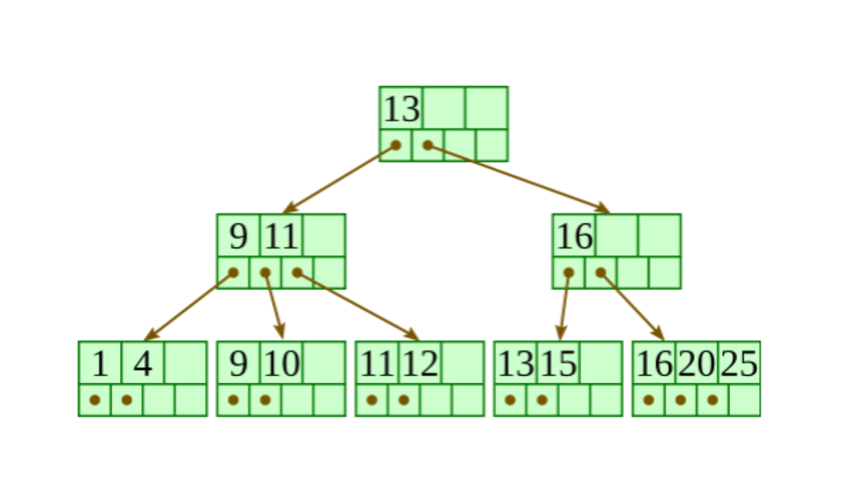

A B+-tree of type $(k,k*)$ is a multi-path tree with the following properties:

* Every node has one more references than it has keys.
* All leaves are at the same distance from the root.
* For every non-leaf node $N$ with $k$ being the number of keys in $N$: all keys in the first child’s subtree are less than $N$’s first key; and all keys in the ith child’s subtree $(2≤i≤k)$ are between the $(i-1)$ th key of n and the $i$ th key of $n$.
* The root has at least two children.
* Every non-leaf, non-root node has at least $floor(d/2)$ children.
* Each leaf contains at least $floor(d/2)$ keys.
* Every key from the table appears in a leaf, in left-to-right sorted order.

There are two operations on a B+ tree that make modifies it:

**Insertion**

* Descend to the leaf where the key fits.
* If the node has an empty space, insert the key into the node.
* *Redistribute Phase*: If the node is already full, split it into two nodes, distributing the keys evenly between the two nodes.
  + If the node is a leaf: take a copy of the minimum value in the second of these two nodes and repeat this insertion algorithm to insert it into the parent node.
  + If the node is a non-leaf: exclude the middle value during the split and repeat this insertion algorithm to insert this excluded value into the parent node.

**Deletion**

* Remove the required key from the node.
* If the node still has enough keys to satisfy the invariant, stop.
* *Redistribute Step*: If the node has too few keys to satisfy the invariants, but its next oldest or next youngest sibling at the same level has more than necessary, distribute the keys between this node and the neighbor. Repair the keys in the level above to represent that these nodes now have a different “split point” between them; this involves simply changing a key in the levels above, without deletion or insertion.
* *Merge step*: If the node has too few keys to satisfy the invariant, and the next oldest or next youngest sibling is at the minimum for the invarant, then merge the node with its sibling; if the node is a non-leaf, we will need to incorporate the “split key” from the parent into our merging. In either case, we will need to repeat the removal algorithm on the parent node to remove the “split key” that previously separated these merged nodes - unless the parent is the root and we are removing the final key from the root, in which case the merged node becomes the new root (and the tree has become one level shorter than before).

**Simple Locking Algorithm**  
The Simple Locking Algorithm is an example of index locking. We set/remove locks in the following way:

* **Search**: We begin at the root and go down. On each level we $rl$ the child and unlock the parent. This until we reach the leaf.
* **Insert/Delete**: We also begin at the root and go down. On each level we $wl$ the child and then check if it is safe. A node is safe if the changes made will not propagate up beyond the node. In insertions, a node is safe if it is not full. In deletions, a node is safe if it not half empty. If the node is safe, then unlock all of its ancestors.

A con of the Simple Locking Algorithm is that the $wl$ that we put on nodes that are not leafs are unnecessary, because only the leaf nodes are modified. The leaf nodes are the only ones that contain data.

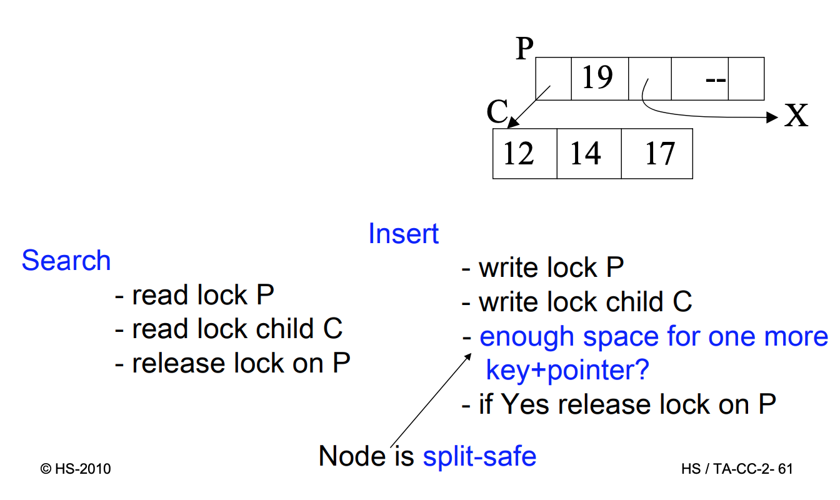

## 2.7 Recovery Protocols

Read or write operations refer to a page of secondary storage.

* **Fetch**: (read operation) transfers a page from the database into the buffer, if the corresponding page is not yet in the buffer.
* **Flush**: after a write operation modifies the content of a page, which must be in the buffer; the page can be written to the database (flushed) at once or later.

Theoretically, all changes on objects $o$ made by $t$ (write operations) should be flushed to disk exactly at commit. Unfortunately this would create a number of problems:

* **Steal** (The risk of Early Disk Writing): usually the operative system and not the database system decides how the pages are used, so the buffer manager might choose to replace the frame in memory which contains the page with the object $o$ (i.e. a frame is stolen from $t$).  
  In this case things are written on the disk before the commit, which could possibly lead to dirty reads.
* **Force** (What about Late Disk Writing?): It is not optimal to always write on the disk at commit points (force), because this creates a lot of disk access requests at the same time and affects performance. If we allow changes to be flushed after commit (no force), the performance would increase.

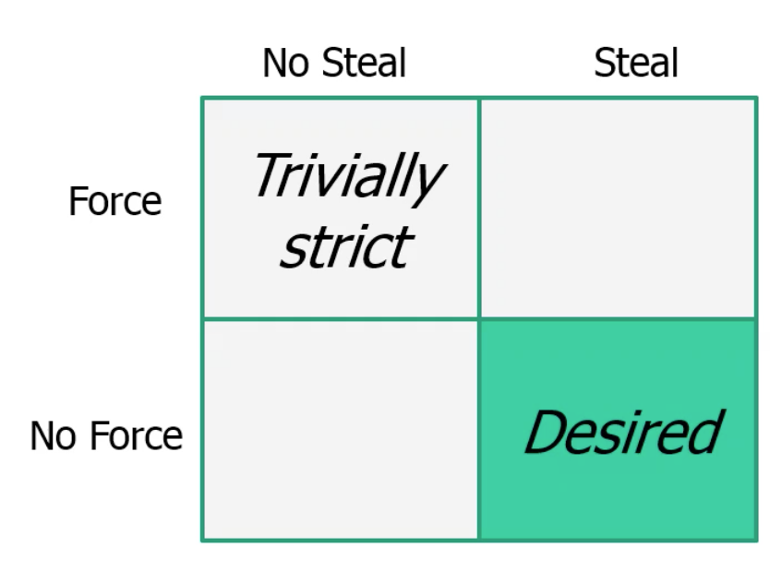

Data Manager and Transaction Manager

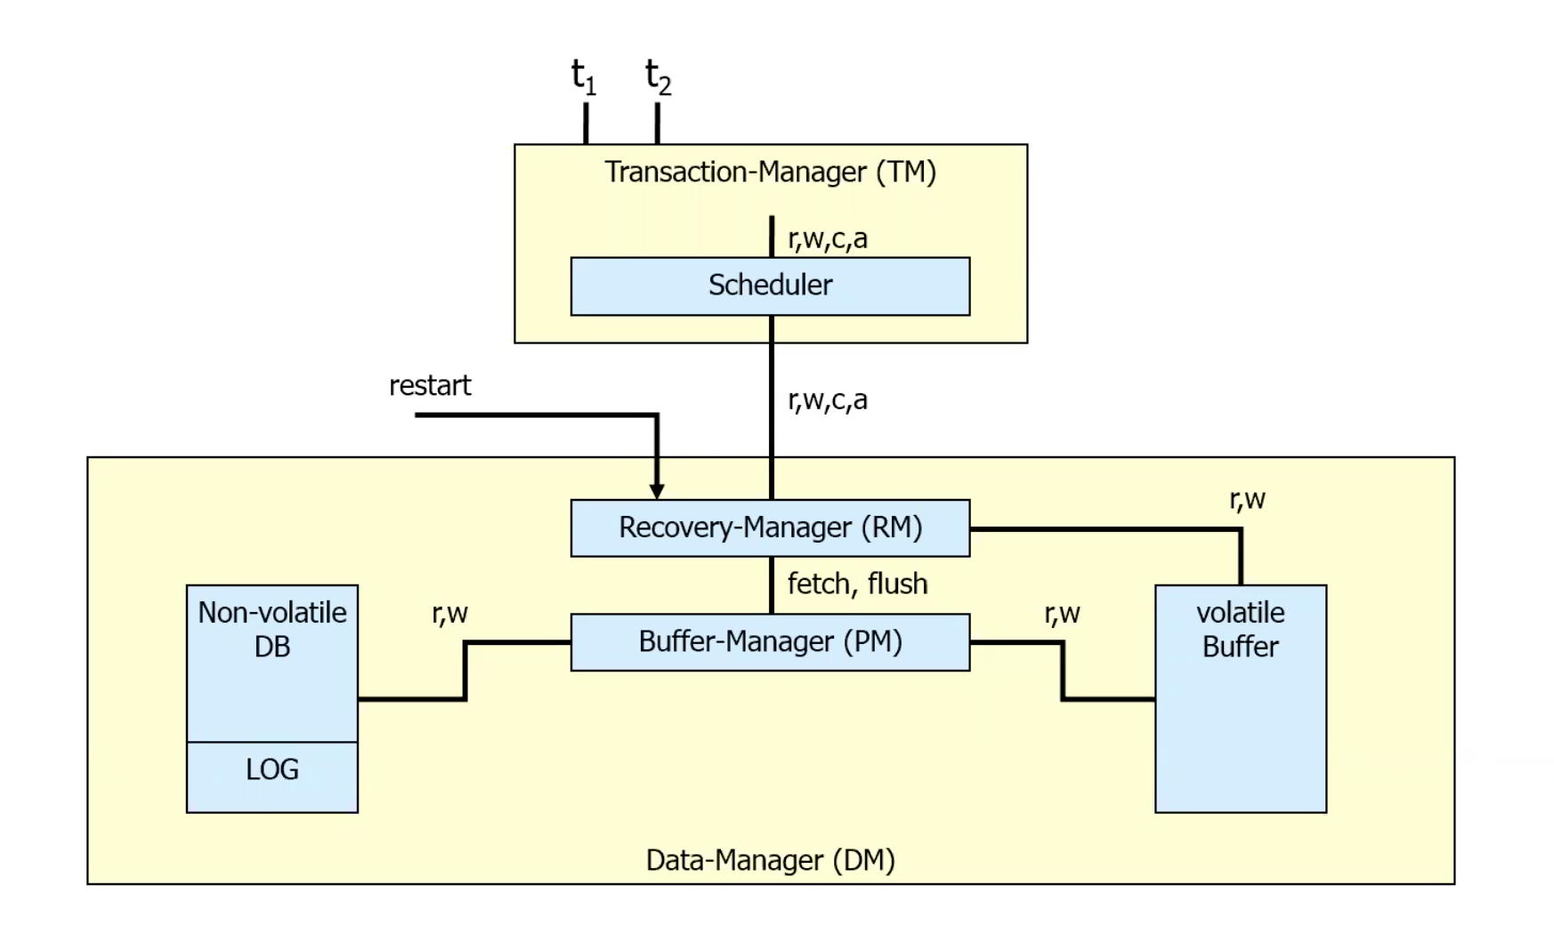

The types of faults, which a DBMS must be able to handle:

1. **Transaction faults**: a transaction does not reach its commit point, e.g. by an error in program or an involvement in a deadlock.
2. **System crash**: parts of (volatile) main memory or buffers get lost, e.g. by errors in DBMS codes, in operating systems or hardwares.
3. **Media fault**: parts of (non-volatile) secondary storage get lost, e.g. by a head crash on a disk, faults in an operating system routine for the writes onto disks.

In the following only fault types (1) and (2) will be considered.

Crash Scenario

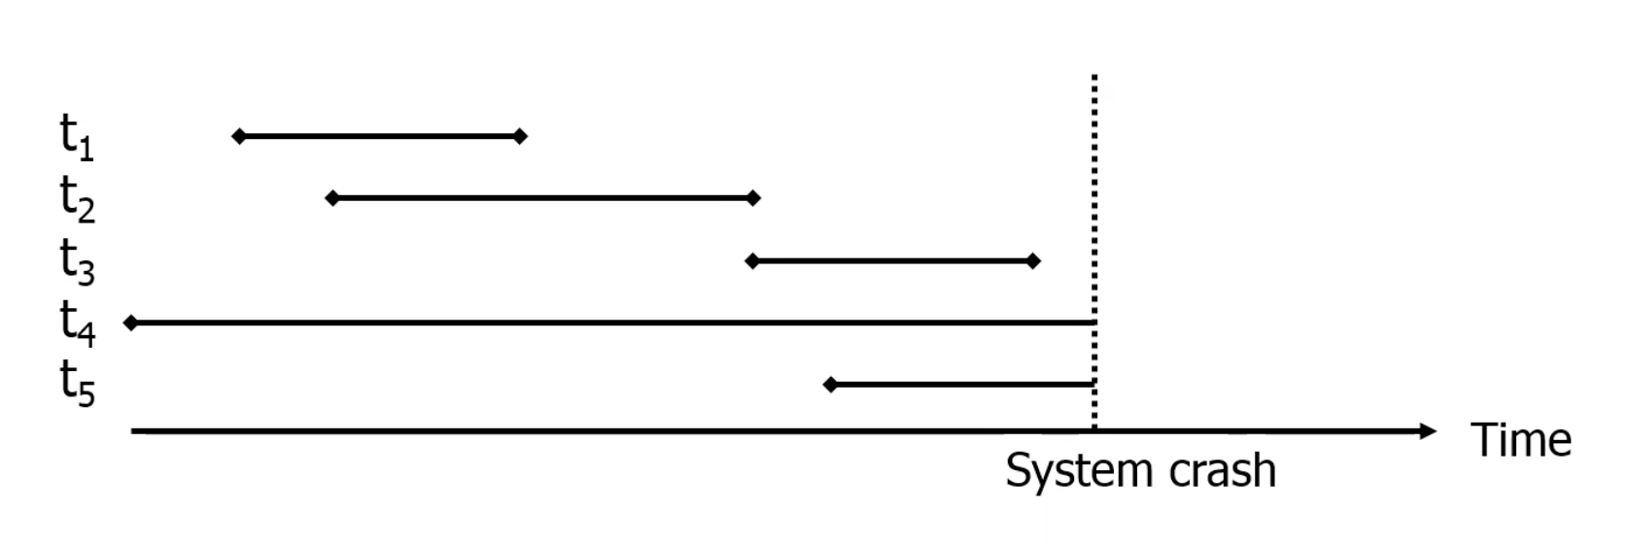

Transactions are classified now in two classes:

* Transactions, which were **already released** before the fault. These need a **REDO**, if results are not permanently stored (No- Force situation).
* Transactions, which were **still active** by the time of the fault. These need an **UNDO**, if some results are already stored on disk (Steal situation).

The Recovery Manager (RM) maintains a **log** file :

* If $t$ wants to write a new value of $x$, a ***Before-Image*** of $x$ is written in the log beforehand (consisting of the ID of $t$, the ID of $x$ and the old value of $x$).
* The new value of $x$ is logged in an ***After-Image*** (consisting of IDs for $t$ and $x$ as well as the new value of $x$).  
  To execute a REDO or UNDO of $t$, the log entries for t are read and processed in reverse sequence. Recovery protocols are classified whether only *After-Images* or only *Before-Images* or both (most systems) are stored.

Any protocol must satisfy the UNDO and REDO rules:

* UNDO-rule („Write-Ahead-Log-Protocol“): The Before-Image of a write operation (the old value of x) must be written into the log, before the new value appears in the stable database.
* REDO-rule(„Commit-rule“): Before a transaction is terminated, every new value that has been written by it must be in the stable storage (in the stable database or in log).

Direct consequence:

* For No-REDO: ensure that all After-Images of a transaction are written in the database before or during the commit.
* For No-UNDO: ensure,that no After-Image of a transaction is written into the database (but only the log) before the commit.

### ARIES

//TODO (CMU lecture 21)

Algorithms for Recovery and Isolation Exploiting Semantics. Developed at IBM research in early 1990s.

Three main principles must be followed:

1. **Write-Ahead-Logging** (to ensure Atomicity and Durability)Must force the log record for an update before the corresponding data page gets to disk. Must write all log records for a transaction before commit.
2. **Repeat History During Redo**: repeat ALL actions of the DBMS before a crash, restoring the exact state at the time of the crash.
3. **Log Changes During Undo**: changes made to the database while undoing a transaction are logged to ensure such an action is not repeated in the event of repeated failures/restarts. This information is written into the log in Compensation Log Records (CLRs).

Fields of a log record: (so that we don’t have to copy the whole page into the log)

* LSN (Log Sequence Number, ID for a Log record)
* TransactionID
* Type (Update, Commit, Abort, End (for End of Commit/Abort), CLR)
* pageID
* Offset (indicates where exactly on the page the change happens)
* Length (how many bytes were changed)
* old data
* new data

## 2.8 Distributed Transactions and the CAP Theorem

//TODO

# 3. Relational Queries

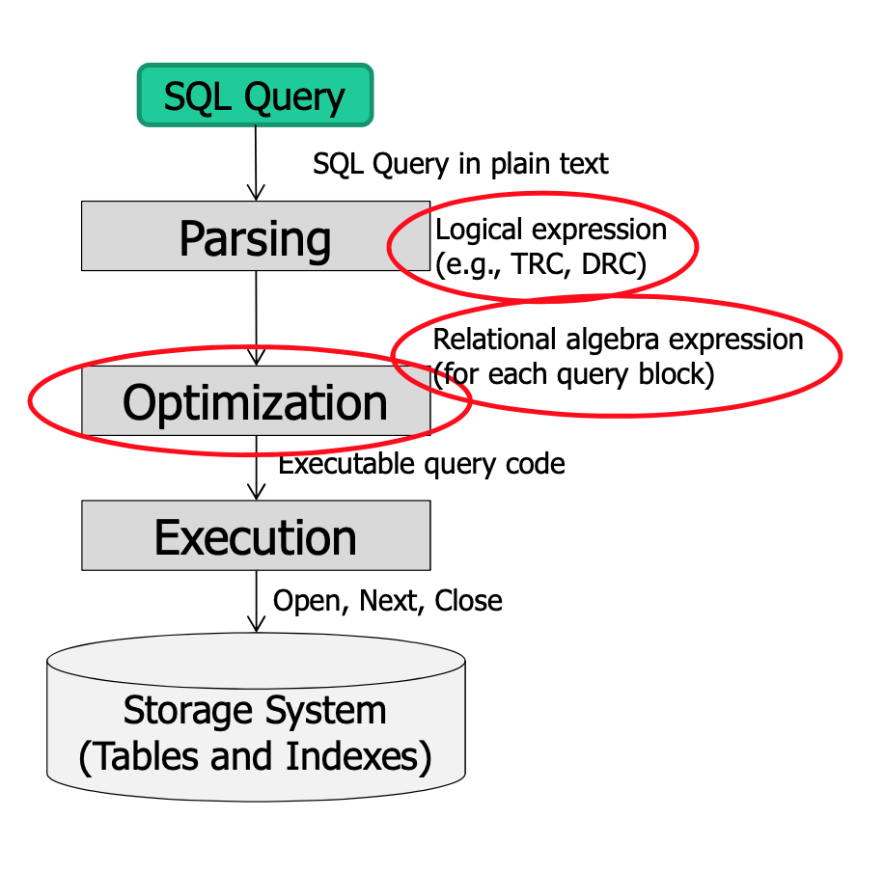

In this chapter the **query evaluation chain** is introduced and it is discussed how clustering and/or indexing can influence the algorithms. First we present the running example that will be used throughout this chapter.

DB Schema

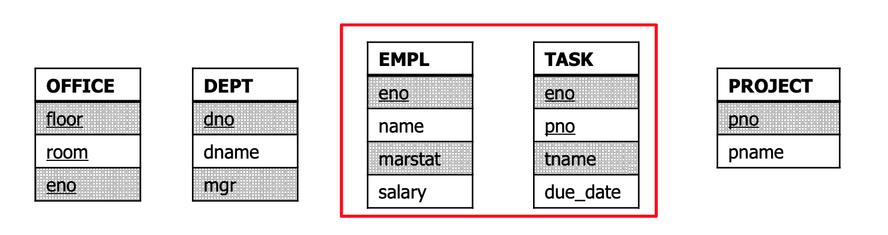

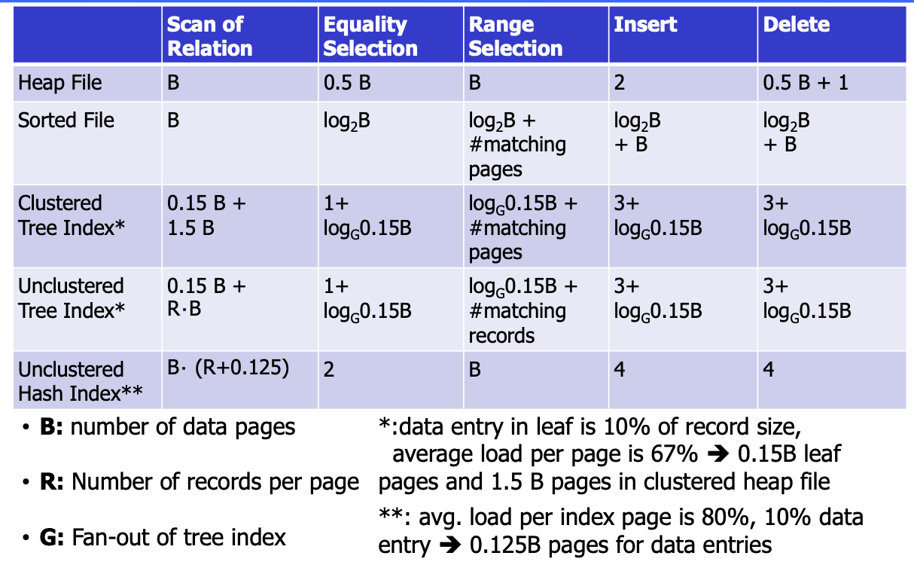

* Sizes:
  + **M** pages in table TASK (1000), $p_{T}$ tuples per page in table TASK (100). Each tuple is 40 bytes. **m** is the total number of tuples, $m=p_{T}⋅M$
  + **N** pages in table EMPL (500), $p_{E}$ tuples per page in table EMPL (90). Each tuple is 50 bytes. **n** is the total number of tuples, $n=p_{E}⋅N$
* Costs:
  + **I/O**: costs for fetching 1 page. Cost Metric: # of IOs to compute operation (e.g. Join)
  + **O-Notation** for complexity of operations
  + No other costs are considered (e.g. for processing of data or data output)

## 3.1 Implementing Single-Relational Operators

//TODO (CMU lecture 10)

### Sorting

### Selection

### Projection, Union and Difference

### Aggregate Functions

## 3.2 Join Algorithms

### Simple Nested Loop

**Cost**: $M+(m⋅N)=M+p_{M}⋅M⋅N=1000+100⋅1000⋅500=50.001.000$ I/Os  
For every tuple in TASK, it scans EMPL once

ANSWER:=[];  
FOR EACH t in TASK DO  
 FOR EACH e IN EMPL DO  
 IF e.salary<40,000 AND e.marstat='single' AND  
 t.tname=‘design' AND t.eno=e.eno   
 THEN ANSWER:+[<e.name>];

### Block Nested Loop Join

**Cost**: $M+(⌈M/(B-2)⌉⋅N)$

Provided we have **B** buffers available. - Use **B-2** buffers for scanning the outer table. - Use one buffer for the inner table, one buffer for storing output.

ANSWER:=[];  
FOR EACH B - 2 block B_T in TASK DO  
 FOR EACH block B_E in EMPL DO  
 FOR EACH tuple t in B_T DO  
 FOR EACH tuple e IN B_E DO  
 IF e.salary<40,000 AND e.marstat='single' AND  
 t.tname=‘design' AND t.eno=e.eno   
 THEN ANSWER:+[<e.name>];

If the outer relation completely fits in memory ($B>M+2$), then the costs are really low: $$M+(⌈M/M⌉⋅N)=M+N$$

### Index Nested Loop Join

**Cost**: $M+(m⋅C)$ $C$ 
: cost of each index probe, depends on the index type (e.g. B+trees, hashing).

ANSWER:=[];  
FOR EACH t IN TASK DO  
 Lookup t.eno in index on Empl.eno, get tuple e from EMPL   
 IF found THEN ANSWER:+[<t,e>];

General tips for nested loop joins:

* Pick the smaller table as the outer table.
* Buffer as much of the outer table in memory as possible.
* Loop over the inner table or use an index

### Sort-Merge Join

**Cost**: $MlogM+NlogN+(M+N)$ $(M+N)$ 
 is the merge cost $MlogM+NlogN$ 
 is the sort cost for the two tables

**Phase #1: Sort**

* Sort both tables on the join key(s)

**Phase #2: Merge**

* Scan the two sorted tables with cursors.
  + Advance cursor of T until  
    current T-tuple >= current E tuple
  + Advance scan of E until  
    current E-tuple >= current T tuple
  + Do this until current T tuple = current E tuple. In that case output matching tuples $<t,e>$ and resume scanning.

### Hash Join

**Cost**: In partitioning phase, read+write both relations; $2(M+N)$. In matching phase, read both relations; $M+N$ I/Os. In total $3(M+N)$.

If tuple $t∈$ TASK and a tuple $e∈$ EMPL satisfy the join condition, then they have the same value for the join attributes. If that value is hashed to some partition $i$, the TASK tuple must be in $t_{i}$ and the EMPL tuple in $e_{i}$.

**Phase #1: Build**

* Scan the outer relation and populate a hash table using the hash function $h_{1}$ on the join attributes.

**Phase #2: Probe**

* Scan the inner relation and use $h_{1}$ on each tuple to jump to a location in the hash table and find a matching tuple.

build hash table HT_R for R  
foreach tuple s in S  
 output, if h_1(s) in HT_R

**Join Algorithms: Summary**

|  |  |  |
| --- | --- | --- |
| Algorithm | IO Cost | Example |
| Simple Nested Loop Join | $$M+(m⋅N)$$ | 1.3 hours |
| Block nested Loop Join | $$M+(m⋅N)$$ | 50 seconds |
| Index Nested Loop Join | $$M+(M⋅C)$$ | Variable |
| Sort-Merge Join | $$M+N+(\text{sort cost})$$ | 0.59 seconds |
| Hash Join | $$3(M+N)$$ | 0.45 seconds |

Hashing is almost always better than sorting for operator execution.

## 3.3 Tableaus

A tableau is a representation for a special class of conjunctive queries in domain relational calculus (DRC):

$$\{a_{1}...a_{m}|∃b_{1}...b_{n}(P_{1}∧P_{2}∧...∧P_{k})\}$$

where $P_{i}$ are atomic predicates (relation predicates or comparisons).

### Tableau Method: Example

SELECT c.name FROM EMPL c, DEPT d, EMPL t  
  
WHERE d.dname='computer' AND c.dno=d.dno AND   
 c.marstat='single' AND t.marstat='single' AND   
 t.salary<40.000 AND c.eno=t.eno  
  
OR d.dname='computer' AND c.dno=d.dno AND   
 c.marstat='single' AND t.marstat='married' AND   
 t.salary<80.000 AND c.eno=t.eno

**Equivalent query in Domain Relational Calculus (DRC)**

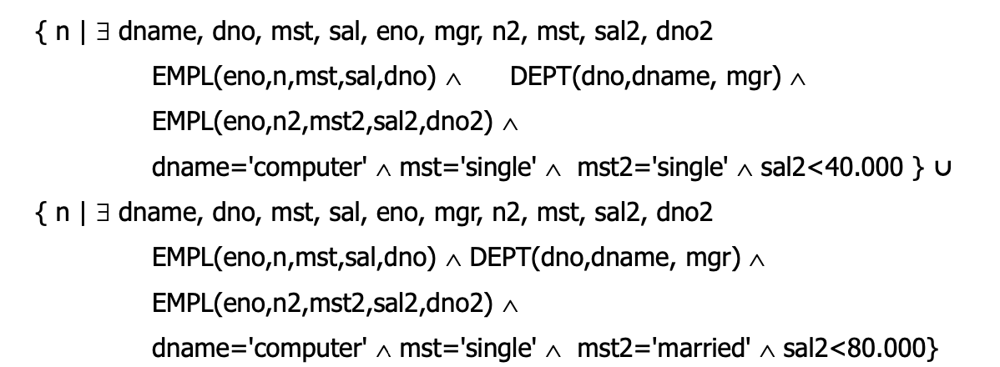

For each relation predicate the tableau contains a row, and for each variable a column.

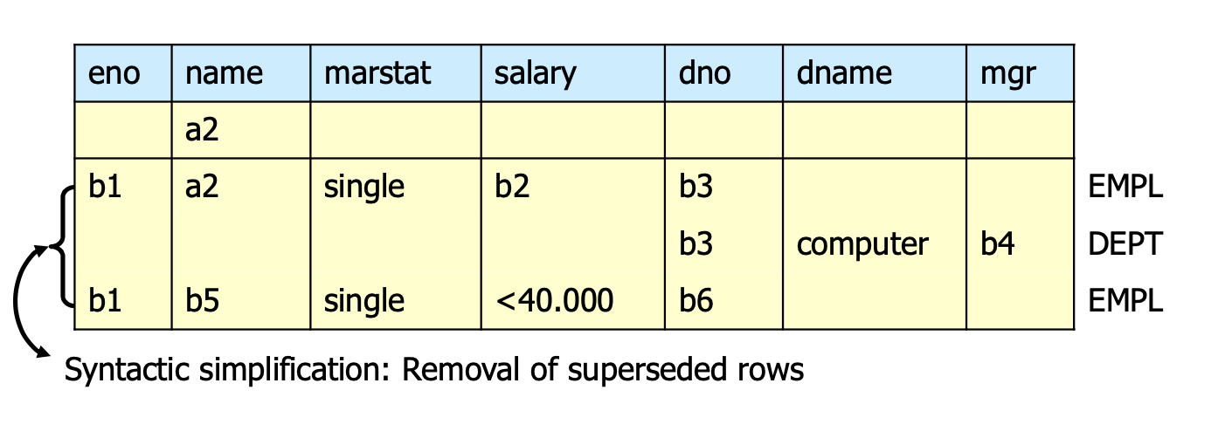

We can replace b5 by a2, b2 by “<40.000” and b6 by b3. We see that the both EMPL rows are the same and we can drop one of them.

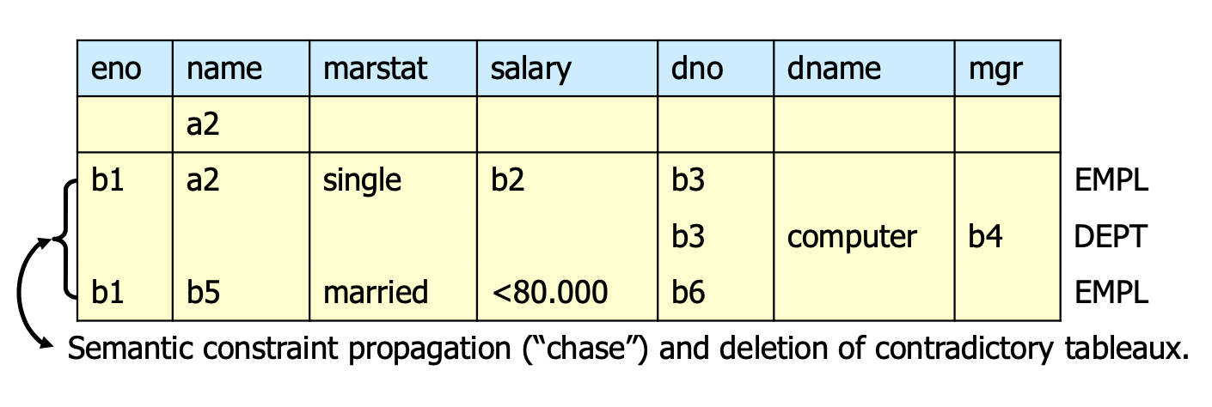

The rows are contradictory in the marital status. We can drop the whole tableau as the join would be the empty set.

**Result tableau**

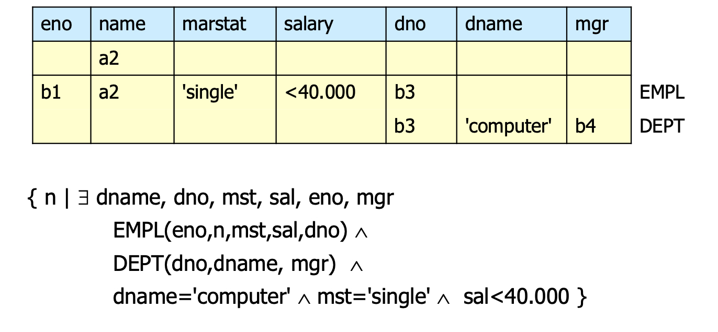

SELECT c.name FROM EMPL c, DEPT d  
  
WHERE d.dname='computer' AND c.dno=d.dno AND  
 c.marstat='single' AND  
 c.salary < 40.000

### Tableau Containment and Equivalence

*Definition 3.1* Tableau $T_{1}$ is **contained** in tableau $T_{2}$ ($T_{1}⊆T_{2}$) if

1. $T_{1}$, $T_{2}$ have the same columns and entries in result rows and
2. The relation computed from $T_{1}$ is a subset of the one from $T_{2}$ for all valid assignments of relations to rows and for all valid database instances.

*Theorem 3.1* (Homomorphism Theorem [Abiteboul et al., 1995]) $T1⊆T2⇔$ 
 There is a homomorphism $h:\{\text{variables of }T_{1}\}→\{\text{variables of }T_{2}\}∪\{\text{constants}\}$ with: 1. $h(\text{fixed row }T_{2})=\text{fixed row }T_{1}$ 2. $h(\text{row }T_{2})=$ any row of $T_{1}$ with the same relation name 3. $h(constant)=constant$ 4. Integrity constraints in $T_{2}$ are transferred to the respective symbols in $T_{1}$ and are also guarenteed in $T_{1}$.

*Theorem 3.2*  
Two tableaux $T_{x}$ and $T_{y}$ are equivalent, denoted as $(T_{x}≡T_{y})$ $⇔T_{x}⊆T_{y}∧T_{y}⊆T_{x}$

**Example:**

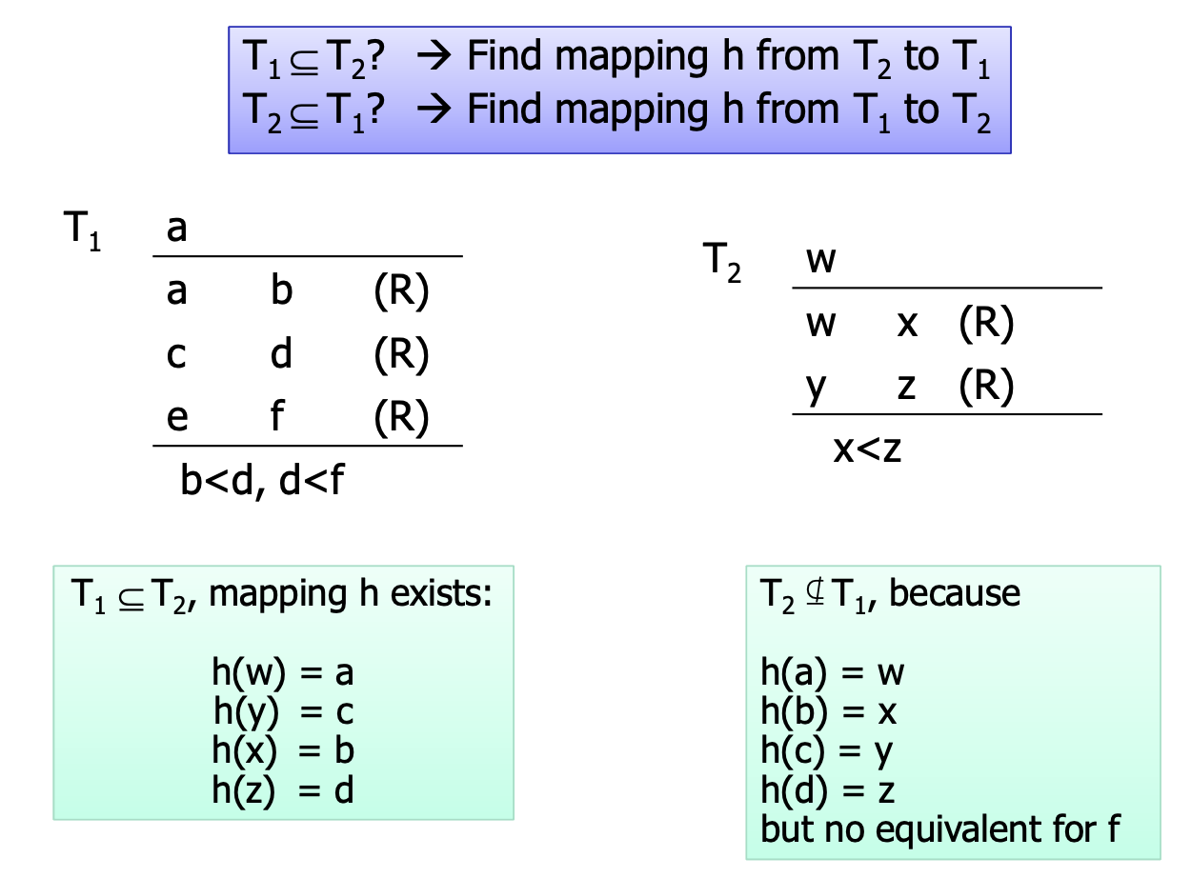 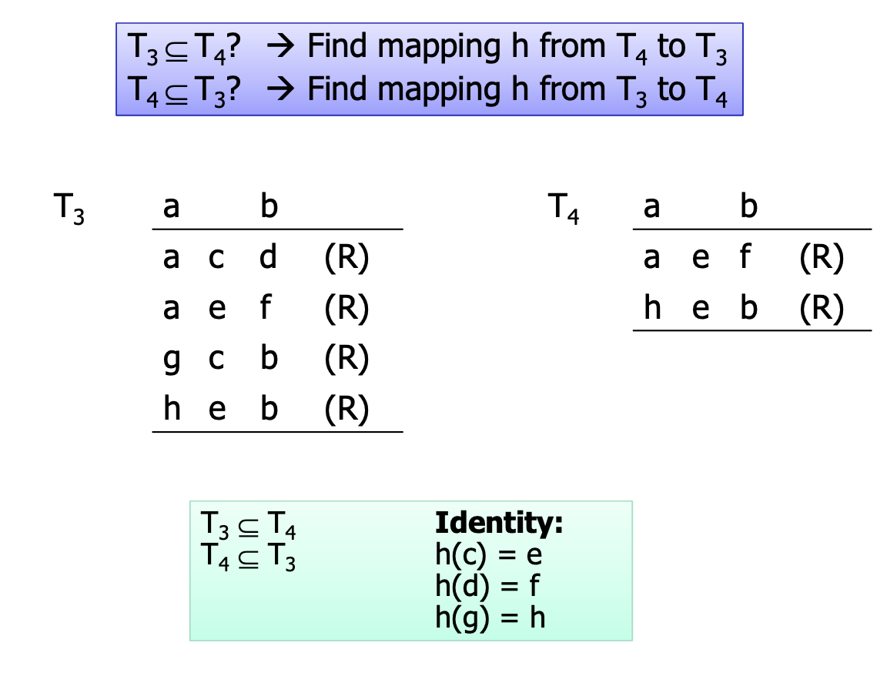

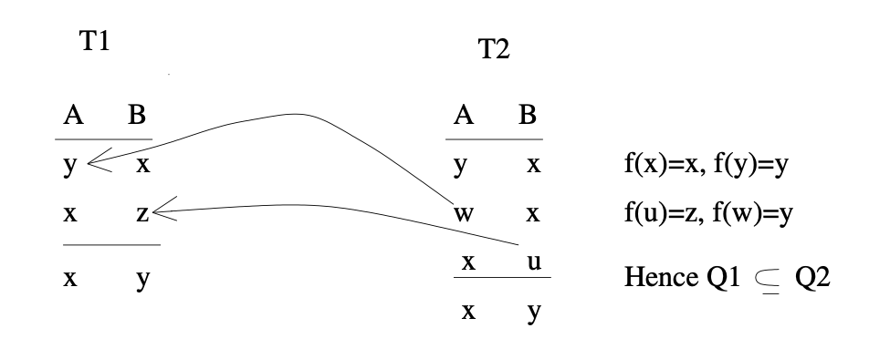 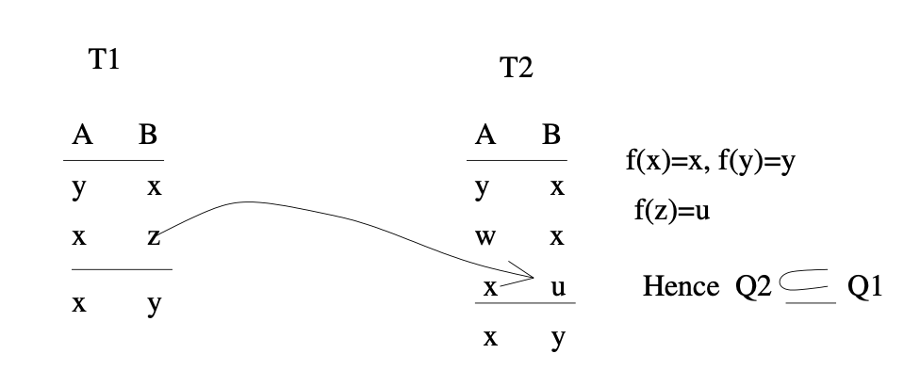

### Tableau Minimization

* For each tableau row: delete the row and check equivalence to original tableau
* Unfortunately, this minimization is NP-complete (no problem for small tableaux)

**Example**:

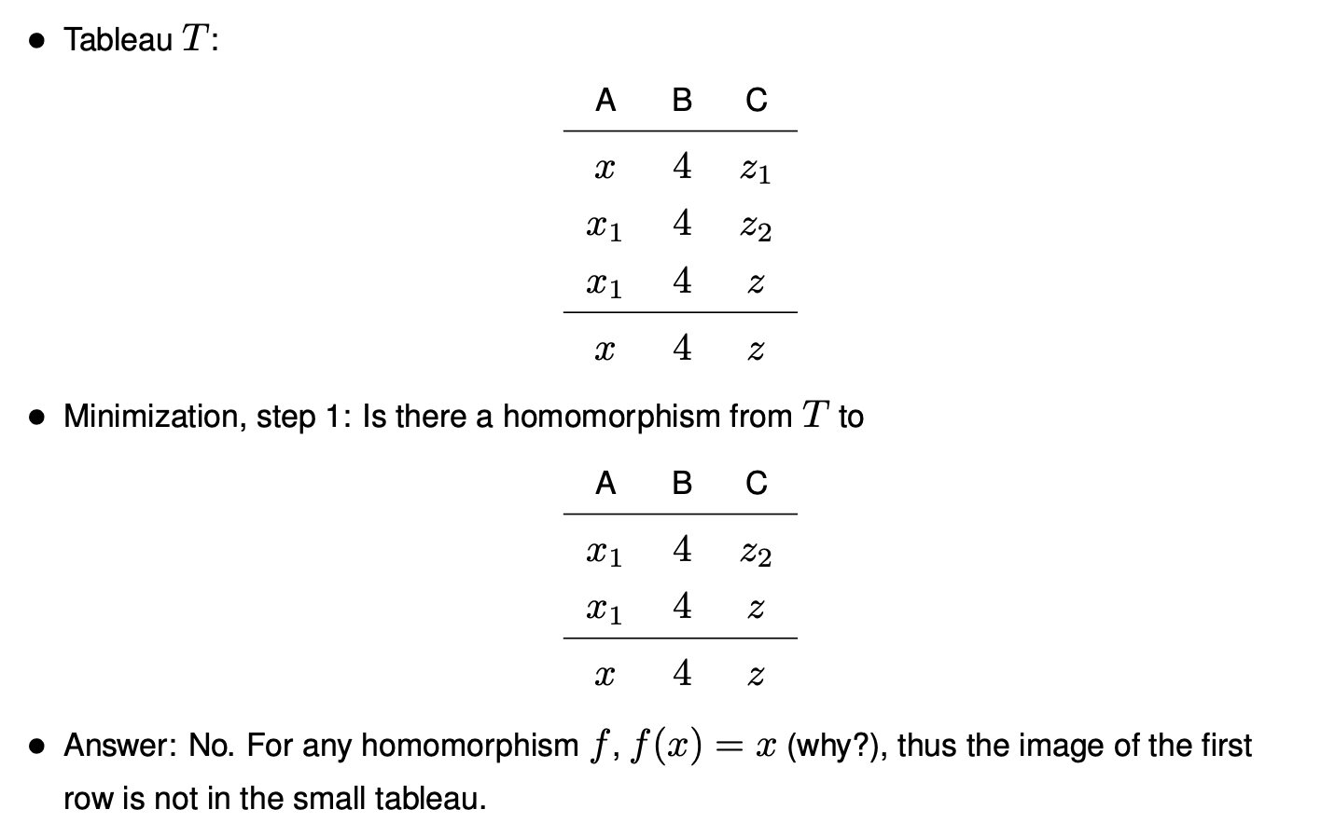 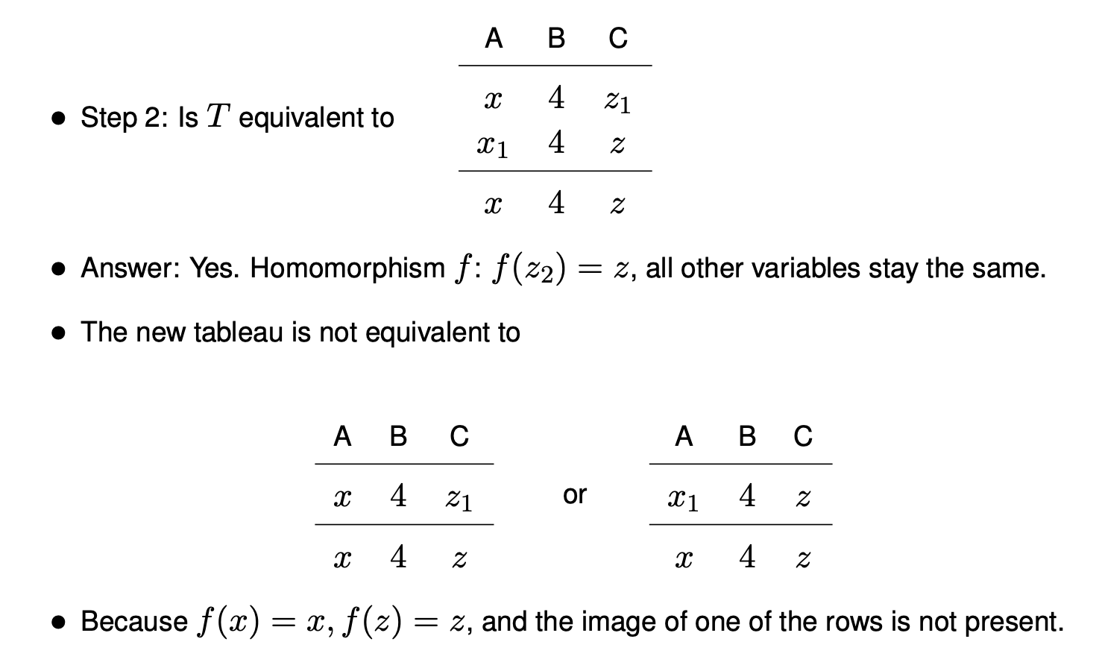 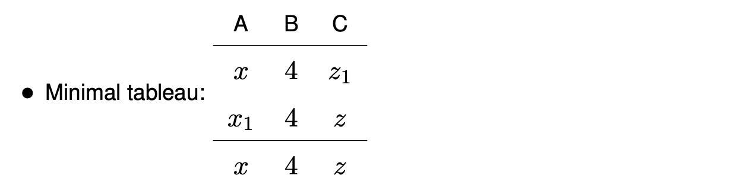

*Theorem 3.3*  
Every minimal tableau is equivalent to the found tableau (except naming).

* Apply integrity constraints (“knowledge-based optimization” using special reasoners, e.g. chase algorithm) to find minimal equivalent tableau
* Key constraints / functional dependencies: If left sides of FDs (keys) are equal in 2 tableau rows, then right sides are equal as well.
* Referential constraints: “pending” rows can be eliminated.
* Domain constraints: Constant propagation and elimination of unnecessary comparisons

## 3.4 Tree-Structured Queries

*Definition 3.2 Semi-Join $R⋉S=Π_{R}(R⋈S)$*  
: The join is projected on the left partner $R$.  
*Theorem 3.4*  
The result of $R⋉S$ is a subset of $R$.  
Thus, the result of a semi-join program $(...((R⋉S)⋉T)⋉...)$ is also a subset of $R$. That means:  
The complexity of a multiway semi-join grows only linearly with the number of semi-joins ( $N⋅k$ instead of $N^{k}$) !

### Definitions

**Range terms** “ $quant_{i}r_{i}∈rel_{i}$” with $quant_{i}∈\{∃,∀,_\}$, $rel_{i}≠∅$, are represented as nodes $k_{i}$.  
**Dyadic comparison terms $d(r_{i},r_{j})$** are represented as directed edges $k_{i}→k_{j}$ and labeled with $d(r_{i},r_{j})$. Is $d(r_{i},r_{j})$, then the label of the edge is $r_{i}=r_{j}$.  
The **direction** of edge $k_{i}→k_{j}$ indicates: $SC(r_{j})⊆SC(r_{i})$ i.e. the edge goes from the table that is left on the semijoin to the table that is left e.g. in b) below these semijoins are carried out: $LECTURES⋉PROFS$, $PROJECTS⋉PROFS$ and $LECTURES⋉PROJECTS$

A **path** between two nodes $k_{i}$ and $k_{j}$ in the Quant Graph is a sequence of edges connecting the nodes.

* **Predicate path**: if all path edges are labeled.
* **Directed path**: if all pairs of adjacent edges have the same direction (otherwise **undirected**).
* Cycle (**predicate cycle**): undirected path (predicate path) connecting a node with itself.

### Quant Graphs

* **Strongly connected**: if for all nodes $k_{i}$ there is an undirected predicate path to every other node $k_{j}$ of the graph.
* **Strictly tree-like**: a strongly connected Quant Graph without cycles (can be directly translated into an equivalent semi-join program).
* **Simply tree-like**: a strongly connected Quant Graph without predicate cycles (can often be rewritten into strictly tree-like by exchanging quantifier sequence)
* **Cyclic**: a Quant Graph with at least one predicate cycle (only a few special cases can be rewritten into tree-like structure, usually requires full join execution (exponential in the size of the cycle).

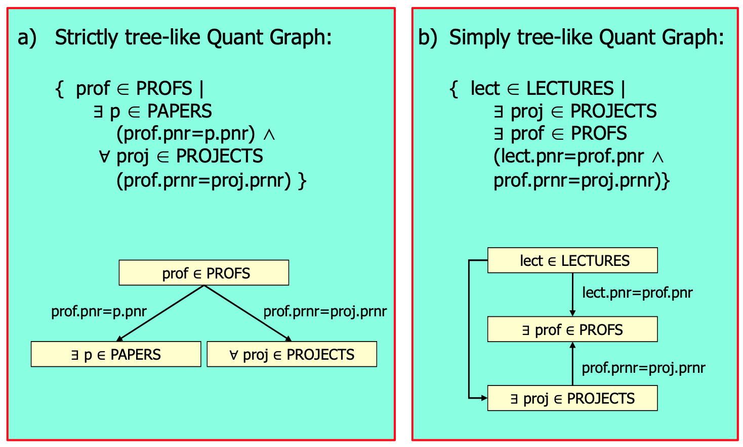

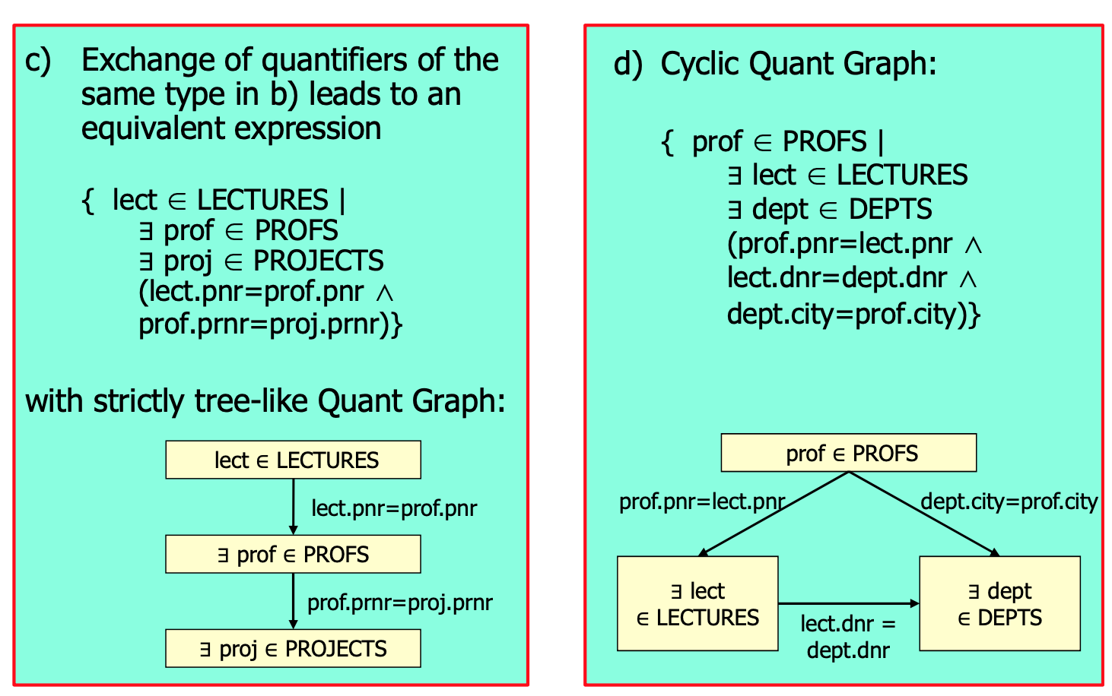

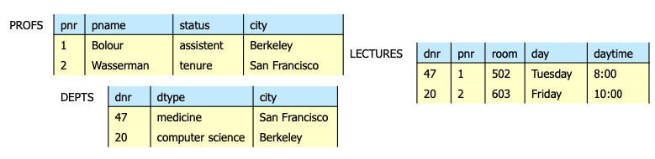

## 3.5 Cost-based Query Optimization

### Selinger-style query optimization

#### Relational Algebra Equivalences

* Selection:
$σ_{c1}∧...∧_{cn}(R)=σ_{c1}(...(σ_{cn}(R)...)$

$σ_{c1}(σ_{c2}(R))=σ_{c2}(σ_{c1}(R))$

* Projection:


* Join:
$R⋈(S⋈T)=(R⋈S)⋈T$

$R⋈S=S⋈R$

* A projection commutes with a selection that only uses attributes retained by the projection.
* Selection between attributes of the two arguments of a cross-product converts cross-product to a join:
$$σ_{R.X=S.Y}(R×S)=R\underset{R.X=S.Y}{⋈}S$$

* A selection just on attributes of $R$ commutes with $R⋈S$
$$σ_{c}(R⋈S)=σ_{c}(R)⋈S$$

* Similarly, if a projection follows a join $R⋈S$, we can ‘push’ it by retaining only attributes of $R$ (and $S$) that are needed for the join or are kept by the projection.
* For each relation $R$:
  + $B(R)$: number of pages needed to store relation $R$.
  + $T(R)$: number of tuples of relation $R$
* For each attribute a of $R$:
  + $V(R,a)$: number of distinct values that relation $R$ has in attribute $a$.

#### Cost Formulas for Single-relation Queries

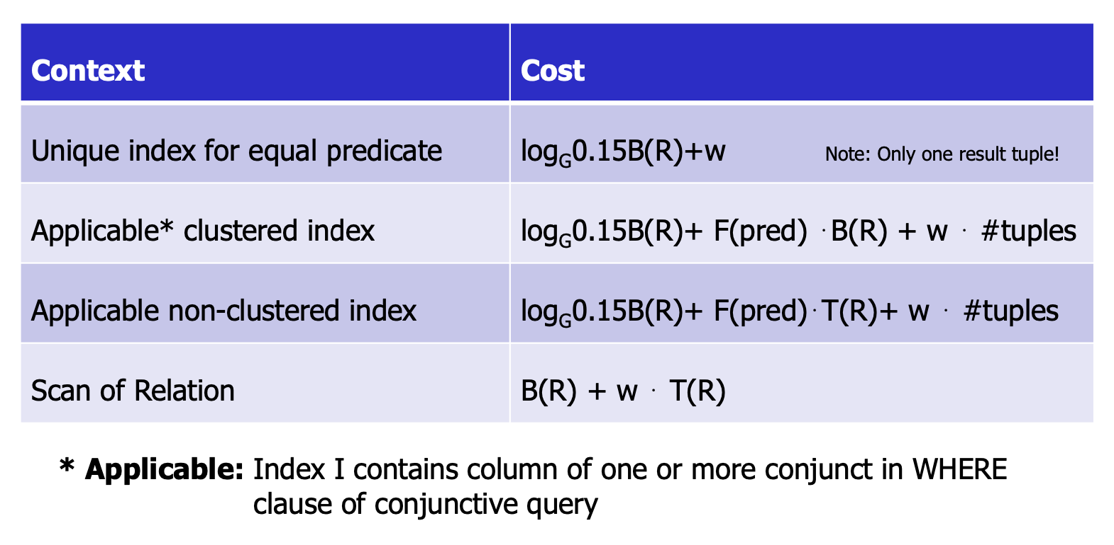

Since the CPUs are much faster now than in the 80s when the formulas were thought out, we now set the $w$ (weighing factor) to 0. $G$ is the size of an index page.

#### Cost Estimation for Join Strategies

**Example**

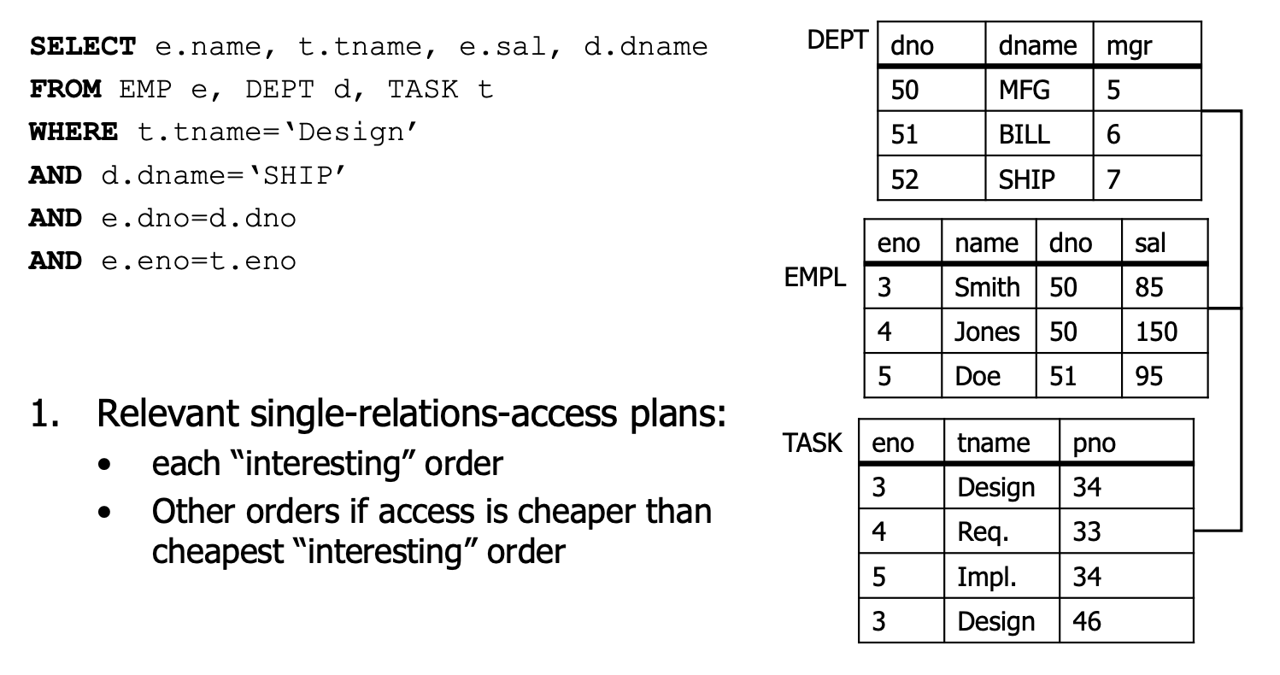 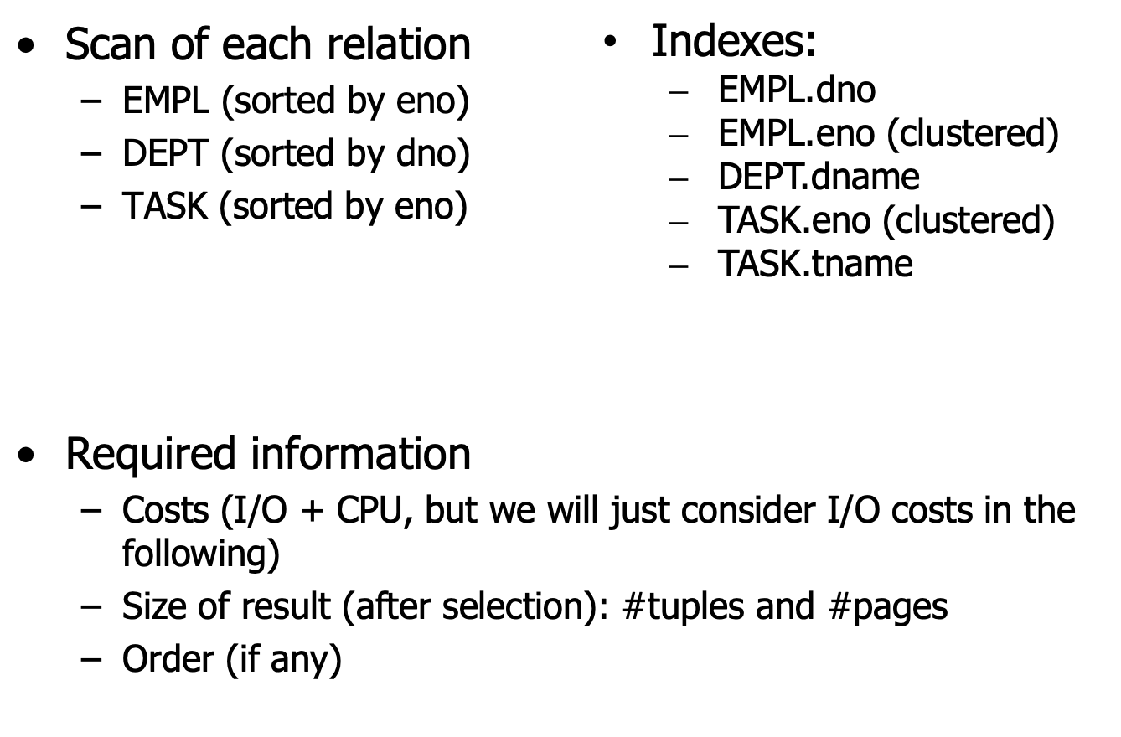 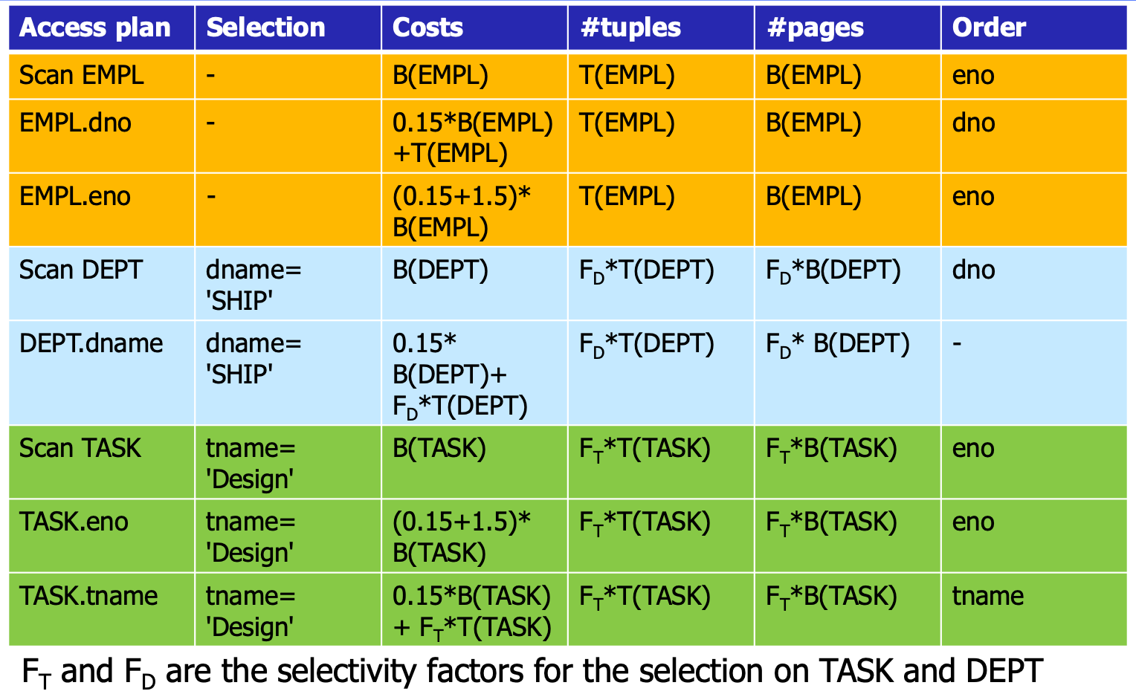 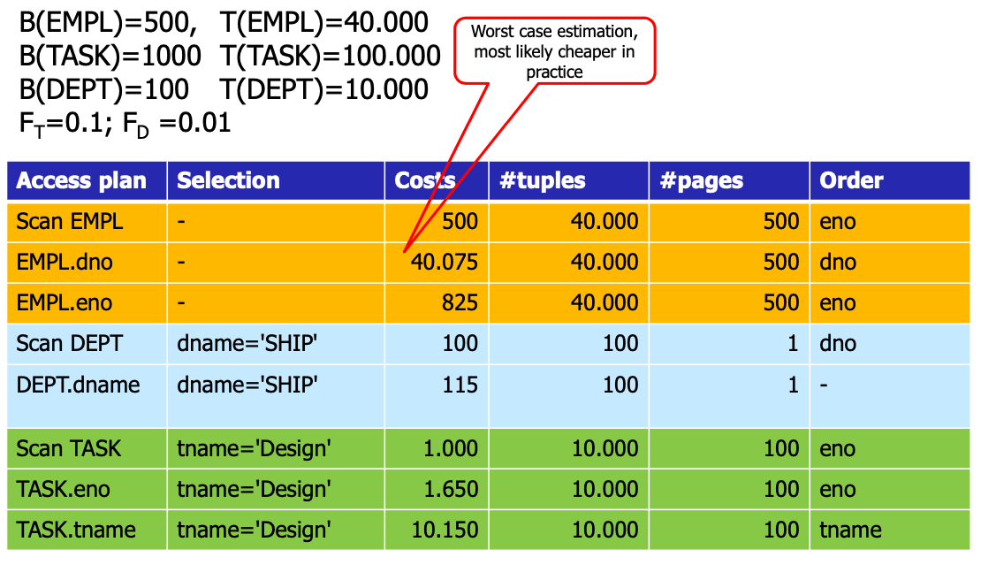 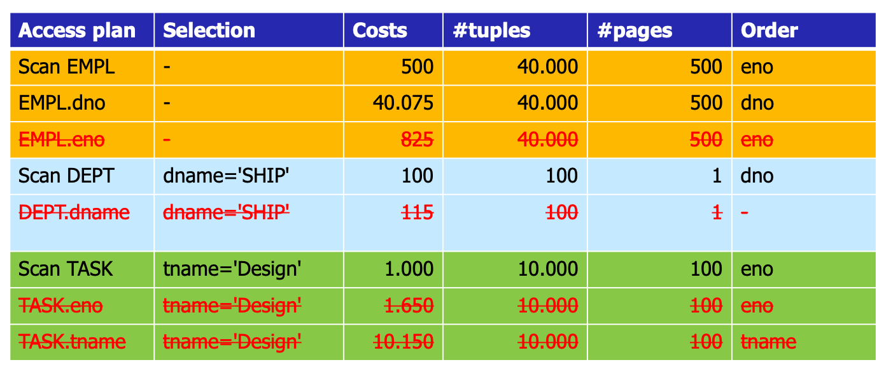 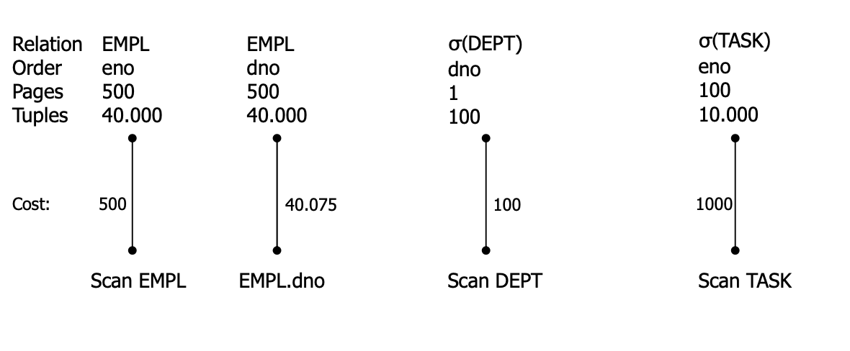 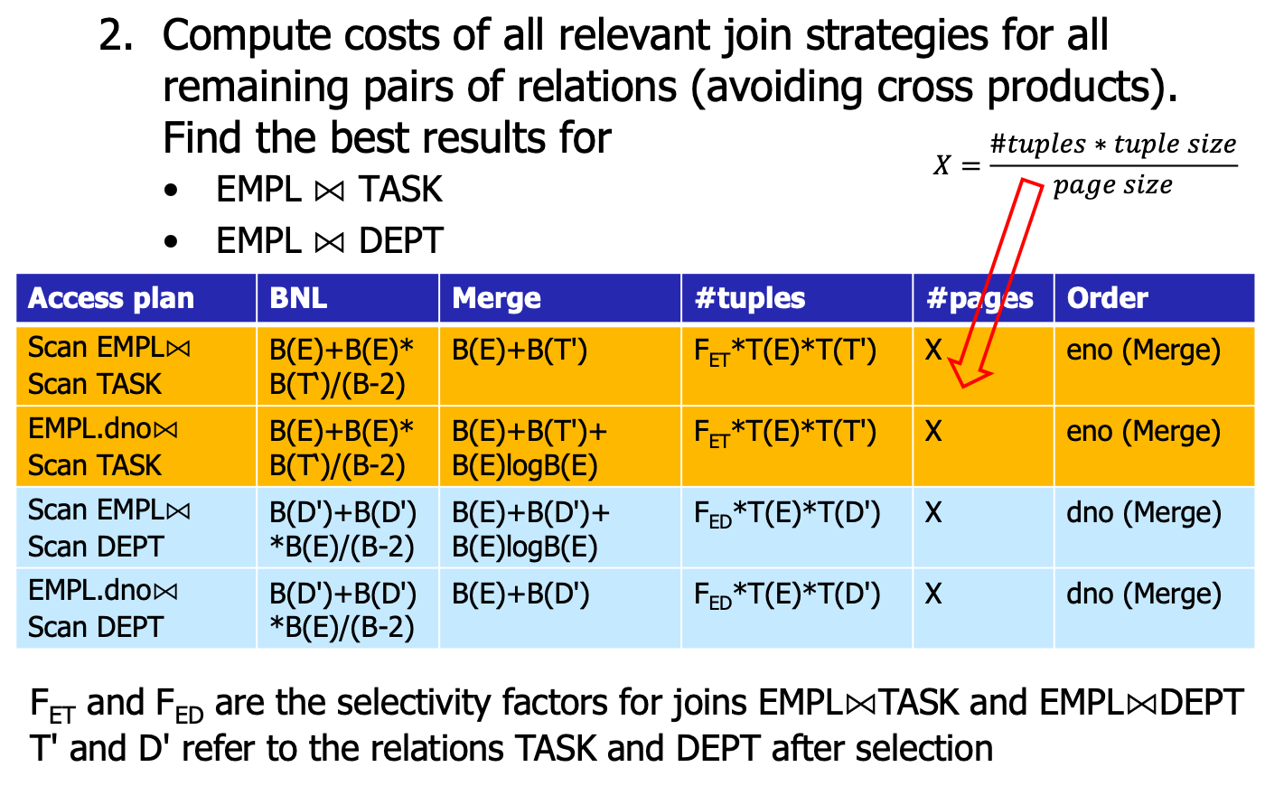 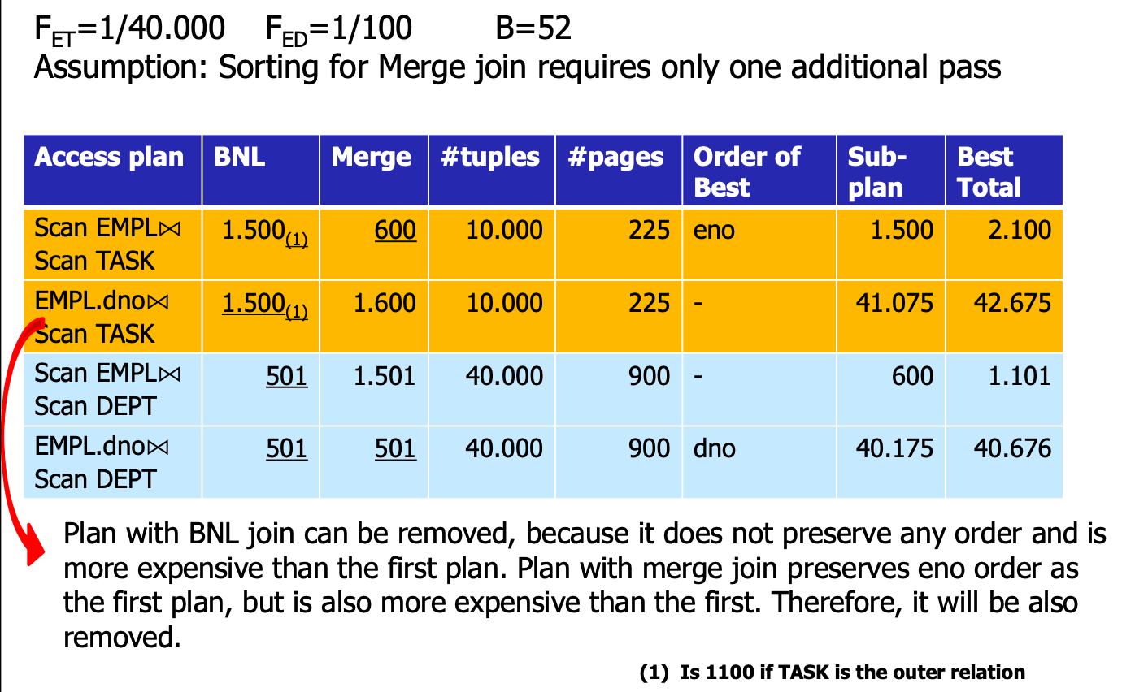 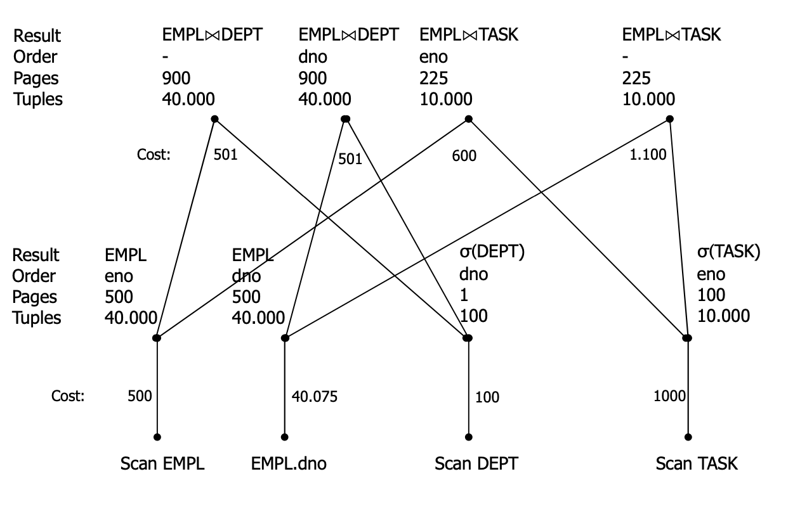 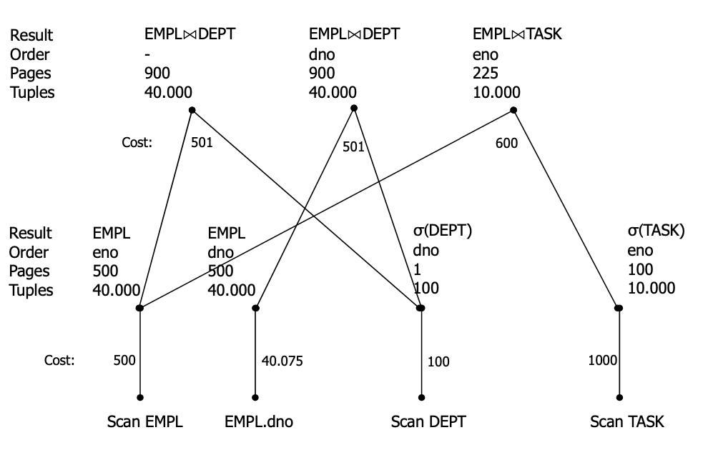 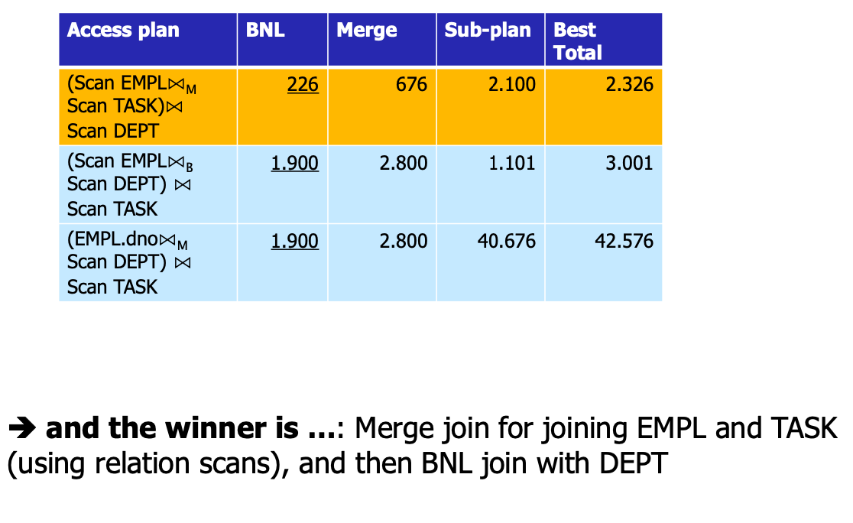

### Views and Indexes

Long term “investment” in access paths. The idea is to store partial results of queries as index or materialized view in the database.

* **Advantage**: Queries can access pre-computed results
* **Disadvantages**:
  + Indexes & Views have to be maintained (higher update costs!)
  + Query processing needs to take into account views & indexes

## 3.6 Deductive Queries & Integrity Checking

Some queries cannot be expressed in SQL or relational algebra (e.g. Give me a list of all parts that are required to build the component X) (e.g. Give me a list of all known ancestors of „John Doe“). A language that allows **recursion**, such as **Datalog** is required.

Organizations use **Data Warehouses** (DWHs) to analyze current and historical data to identify useful patterns and support business strategies. The emphasis is on complex, interactive, exploratory analytics of very large datasets created by integrating data from across all parts of an enterprise. Data is fairly static. DWHs are focused on queries rather than updates (read rather than write).

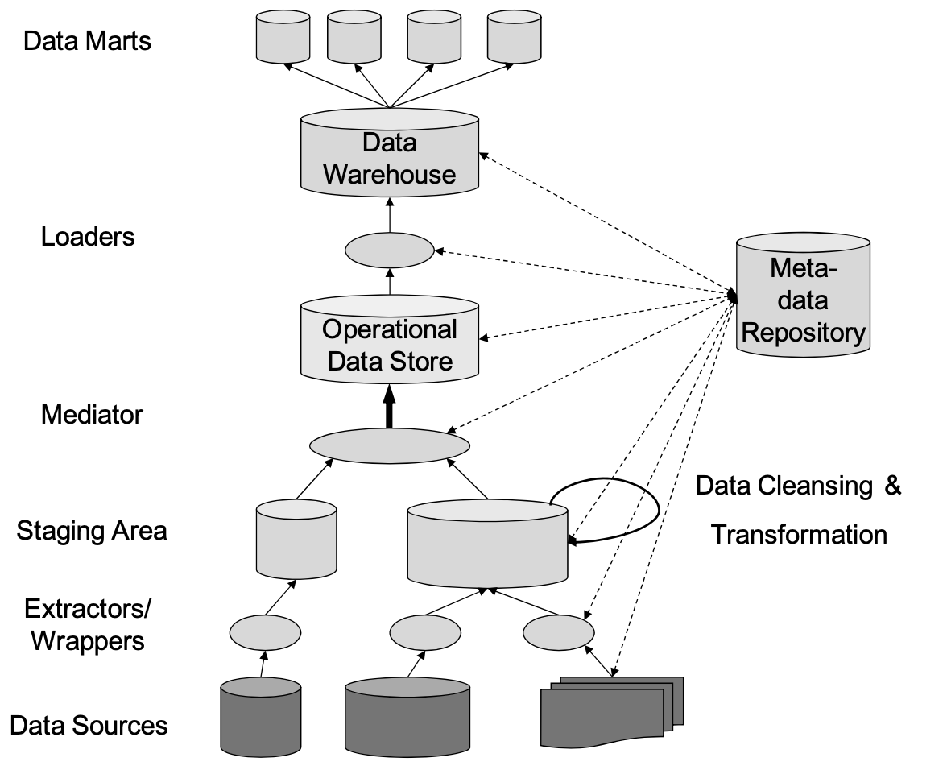

### Datalog Syntax

**Rules** are Horn-clauses in the form $p\text{:- }r_{1}∧r_{2}∧...∧r_{k}$, where $p$ and $r_{i}$ are relation predicates. e.g.

$$p(X,Y)\text{:- }r_{1}(X,Z)∧r_{2}(Z,Y)$$

$$manager(SSN,N)\text{:- }empl(SSN,N,M,S,D)∧dept(D,DN,SSN)$$

**Queries** are written either with the head “?-” at the beginning, e.g.

$$\text{?- }empl(SSN,N,_,_,D)∧dept(D,\text{’computer’},_)$$

, or with the special query predicate, e.g.

$$q(X,Y)\text{:- }r_{1}(X,Z)∧r_{2}(Z,Y)$$

**Constraints** are rules without head that must be always false, e.g. $\text{:- }empl(S,N,M,Salary,D)∧Salary<10.000$

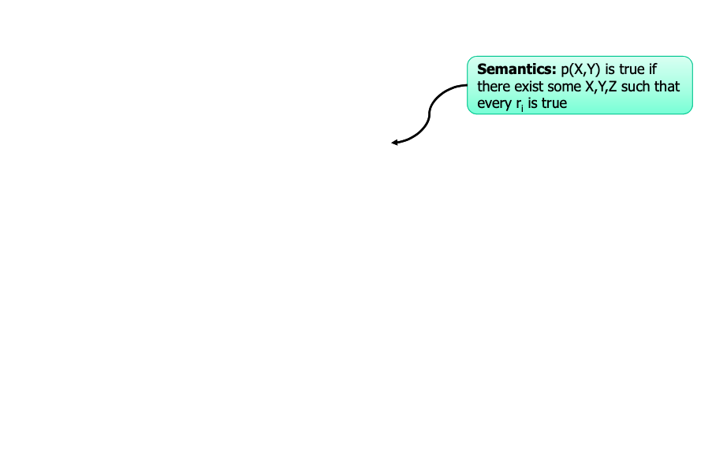

### Deductive Databases (DDBs)

A **deductive database** consists of a set F of facts, a set R of deduction rules, a set IC of integrity constraints and the set F* of all explicit and derived (implicit) facts. Deductive Database $D=(F,R,IC)$

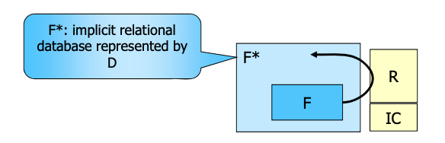

* **EDB**: extensional DB
  + Relations defined as a set of facts in F
  + Base relations
  + Set of facts
* **IDB**: intensional DB
  + Relations defined by rules in R
  + Derived relations

There are two variations of Datalog. **Datalog $¬$**, where negation is allowed and **NR-Datalog**, where recursion is not allowed.

**Herbrand Base of D**: all positive ground literals are constructable from predicates in D and constants in D.  
**Herbrand Model of D**: any subset M of the Herbrand Base of D, such that: each fact from F is contained in M. For each ground instance of a rule in D over constants in D, if M contains all literals in the body, then M contains the head as well. A minimal model does not properly contain any other model. F* is formally defined as the minimal Herbrand model of D.

#### Example (NR-Datalog)

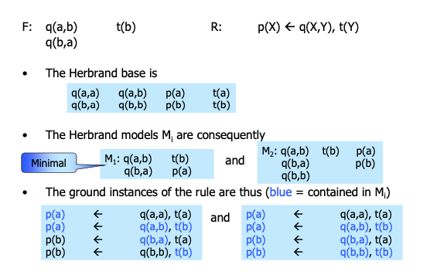

#### Least Fixpoint for NR-Datalog

F* is created by the repeated (finite) application of the immediate consequence operator $T_{D}$ (naive evaluation strategies) starting from F results in derivation of implicit facts from F:

$$T_{D}(T_{D}(....(T_{D}(F))...))$$

For a subset S of a Herbrand Base the application of $T_{D}$ to S is defined as:

$$T_{D}(S):=\{H:(H←B)\text{ is a ground instance of a rule such that S contains all}\text{ literals in B}\}$$

**Theorem**: The uniquely determined least fix point of $T_{D}^{*}$ is the minimal Herbrand Model of D.

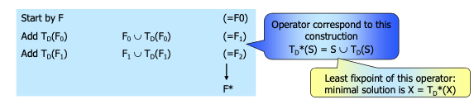

//TODO

**Integrity constraints** (IC) are conditions that have to be satisfied by a database at any point in time (expressing general laws which cannot be used as derivation rules). **Integrity-checking** tests whether a particular update is going to violate any constraint. The main problem with IC-Tests is that a full evaluation of all ICs before every update would be very expensive and would decrease update performance significantly. The solution is to determine a reduced set of simplified ICs for which the checking guarantees satisfaction of all ICs. This approach leads to a specialization of constraints.

## 3.7 Querying Data Integration Systems

**Data integration** is the problem of providing unified and transparent access to a collection of data stored in multiple, autonomous, and heterogeneous data sources

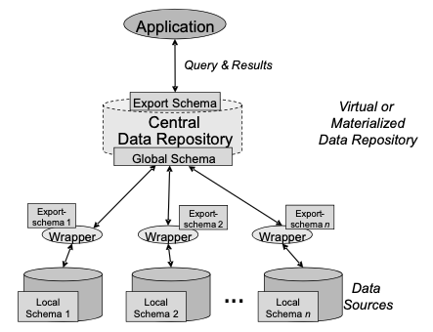

How to specify the **mapping** between the data sources and the global schema?

* **LAV**(local-as-view): The sources are defined in terms of the global schema (i.e. as view on the global schema) – we can thus talk about completeness of sources with respect to global world knowledge
* **GAV** (global-as-view): The global schema is defined in terms of the sources (i.e. as view on the source schemas) – this is more obvious for query processing (view unfolding) but the relationship among the sources (e.g. real-world objects with different ID‘s in the sources) must be explicitly managed
* **GLAV**(combination of GAV and LAV)

#### Example

Source Schema S

* em50(Title, Year, Director) *European movies since 1950*
* rv10(Movie, Review) *reviews since 2000*

Global Schema G

* movie(Title, Director, Year)
* ed(Name,Country,Dob)*(European directors)*
* rv(Movie, Review)

Query q

SELECT M.title, R.review  
FROM Movie M, RV R  
WHERE M.title=R.title AND M.year = 2010

We have to prove that queries are equivalent or contained in each other:

* **Query Equivalence**: q and q’ are equivalent if they produce the same result for all legal databases
* **Query Containment**: q is contained in q’ if the result of q is a subset of the result for q’ for all legal databases

#### GAV example

* movie(Title, Director, Year) :- em50(Title, Year, Director).
* ed(Name) :- em50(*,*,Name).
* rv(Movie, Review) :- rv10(Movie,Review).

*Note that the global schema will not know that it cannot find reviews and movies over a certain age*

Queries over G can be rewritten as queries over S by unfolding

* q(Title, Review) :- movie(Title, _, 2010), rv(Title,Review).
* $⇒$ q’(Title, Review) :- em50(Title, 2010,_), rv10(Title,Review).

#### LAV example

* em50(Title,Year,Director) :- movie(Title, Director, Year), ed(Director,Country,Dob), Year $≥$ 1950.
* rv10(Movie,Review) :- rv(Movie,Review), movie(Movie,Director, Year), Year $≥$ 2000.

*Here, the view definition explicitly includes the temporal limitations of knowledge about the real world of movies and reviews, thus informative answers to queries outside the boundaries of this knowledge can be given.*

The idea is to try to cover the predicates of the query by predicates in the bodies of the source views

* q(Title, Review) :- movie(Title, _, Year), rv(Title,Review), Year = 2010.

*The sources defined as materialized views on the global schema:*

* em50(Title,Year,Director) :- movie(Title, Director, Year), ed(Director,Country,Dob), Year ≥ 1950.
* rv10(Movie,Review) :- rv(Movie, Review), movie(Movie, Director, Year), Year ≥ 2000.

*Answering queries using these views:*

* qrewritten(Title, Review) :- rv10(Title,Review), em50(Title,Year,_), Year = 2010.

# 4. Big Data & Internet Information Systems

## 4.1 Query Processing in Big Data Systems

### Map-Reduce

Map-Reduce is a programming pattern for parallel computation in distributed system. It is defined by two functions:

* **Map(data) $→$ (key,value)**: it reads the input data and emits key-value pairs. Note that the keys are not necessarily unique in emitted pairs.
* **Reduce(key,values) $→$ (key,values)**: it gets input from Map function, which is a set of values for a single key. Note that the input and output structure should be the same and that some implementations require that output is a single value. Furthermore, Reduce can be called multiple times for the same key.

#### Simple Example (in MongoDB syntax)

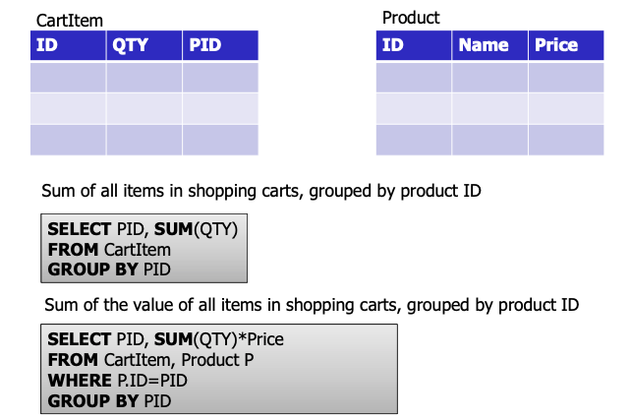 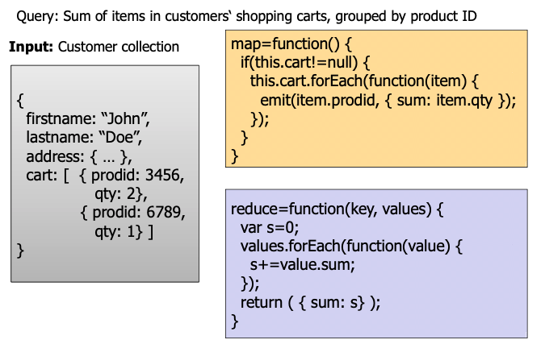

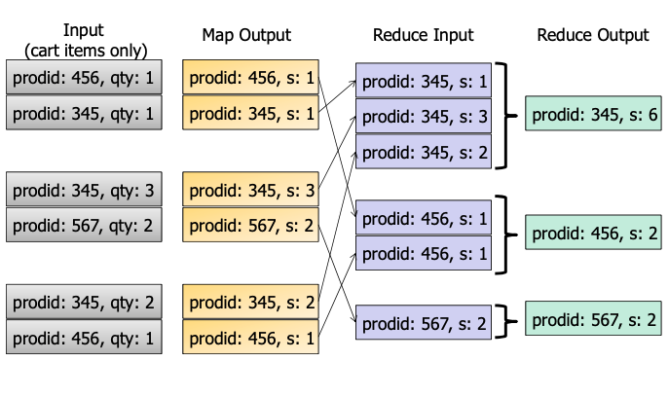

#### Complex Example (Join between customers and products)

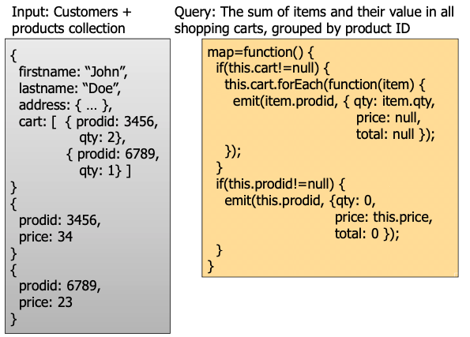 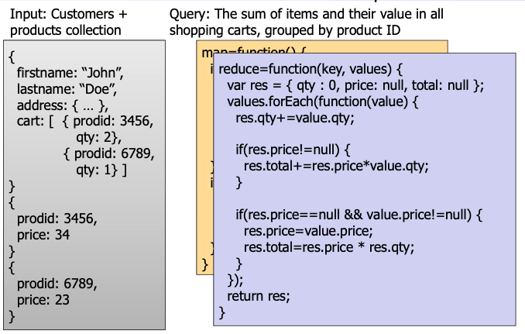

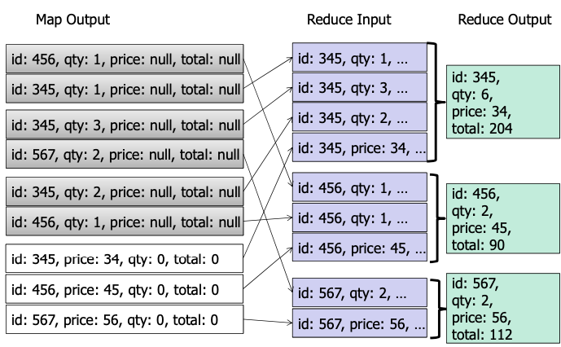

## 4.2 Data Management in the Cloud